Pacific Regional Invasive Species Management Support Service
Protect our Islands Programme
Early Detection and Rapid Response Protocols for Ants

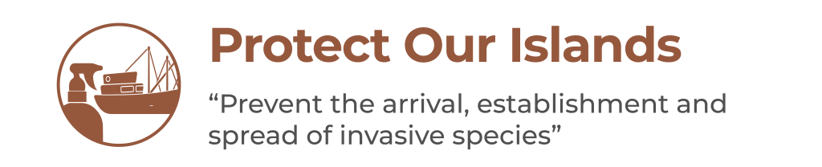

Contents
1 Acknowledgements 2
2 Introduction 3
3 PRIORITISE 4
3.1 Prioritise risk species 4
3.1.1 Red imported fire ant (Solenopsis invicta) 4
3.1.2 Little fire ant (Wasmannia auropunctata) 5
3.1.3 Yellow crazy ant (Anoplolepis gracilipes) 5
3.2 Identify risk pathways for priority species 6
3.2.1 International pathways 6
3.2.2 Domestic pathways 7
3.2.3 Highest risk pathways for ants 7
3.2.4 Vectors and pathways for the Pacific's 18 worst threat ants 7
4 PREPARE 9
4.1 Define EDRRP area 9
4.2 Decide on treatment products, training and tools 9
4.2.1 Treatment products 9
4.2.2 Training 10
4.2.3 Equipment 10
4.3 Obtain permits 11
4.3.1 Environmental and social impact considerations 11
4.3.2 Some things to think about when preparing your environmental permit / licence application and EIA/ESIA 12
4.3.3 Pesticides used for ants 13
4.3.3.1 1. Neurotoxins 13
4.3.3.2 2. Stomach poisons 13
4.3.3.3 3. Insect growth regulators 13
4.3.4 Toxicity 14
4.4 Estimate costs and order products 14
4.4.1 Detailed costing 14
4.4.2 Suppliers of treatment products 16
4.5 Train the team 17
4.6 Source / produce awareness materials 17
5 DETECT 19
5.1 Active surveillance 19
5.1.1 Visual Surveys 19
5.1.2 Attractive lures 23
5.2 Passive surveillance 26
6 RESPOND 26
6.1 Identification 26
6.2 Containment 33
6.3 Delimiting 35
6.4 Continued surveillance 35
6.4.1 Red imported fire ants 35
6.5 Treatment activities 35
6.5.1 Notify public and stakeholders 35
6.5.2 Monitoring 36
6.5.2.1 1. Evaluating treatment success 36
6.5.2.2 2. Evaluating if treatment is required (not applicable to EDRR) 36
6.5.2.3 3. Monitoring non-target effects 36
6.5.3 Undertake treatments 37

Acknowledgements
These protocols were derived from the Pacific Invasive Ant Toolkit by Monica Gruber, Pacific Biosecurity.
The EDRR framework was developed for the Protect our Islands programme by Pacific Biosecurity under the Regional Invasives Project (GEF 6 RIP) - Strengthening national and regional capacities to reduce the impact of Invasive Alien Species on globally significant biodiversity in the Pacific. The GEF 6 RIP is funded by the Global Environment Facility (GEF), implemented by the United Nations Environment Programme (UNEP), and executed by the Secretariat of the Pacific Regional Environment Programme (SPREP).

Introduction
These protocols should be read in conjunction with the country EDRR plan. The protocols provide the technical information needed to conduct EDRR and are generally structured based on the EDRR checklist: PRIORITSE, PREPARE, DETECT, RESPOND.
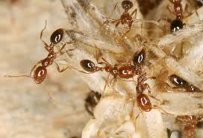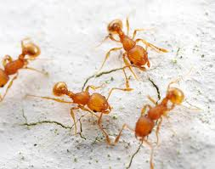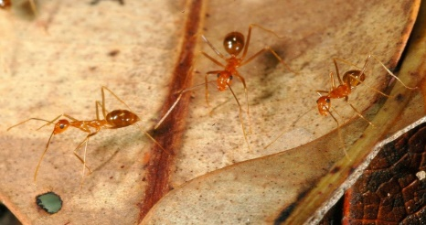
Red imported fire ants
© Benoit Guenard
Little fire ants
© Alex Wild
Yellow crazy ants
© Phil Lester
The protocols provide the technical information needed to conduct EDRR and are generally structured based on the EDRR template: PRIORITSE, PREPARE, DETECT, RESPOND. Most of this section is taken directly from Pacific Invasive Ant Toolkit: http://piat.org.nz/

PRIORITISE
In this section:
- Identify risk species and pathways
  - Prioritise risk species
  - Identify risk pathways for priority species

Prioritise risk species
The Pacific Invasive Ant Toolkit (the PIAT) outlines the major threat invasive ant species. Some of these are already in the Pacific (such as little fire ant, yellow crazy ant) and some are not yet present (such as red imported fire ants).
The information focus provided here is on the three major species (little fire ant, yellow crazy ant, and red imported fire ant). However, some information for other species is also included. For other priority species for the Pacific, information can be extracted from the PIAT.
SOURCES:
Pacific Invasive Ant Toolkit: Problem ants http://piat.org.nz/index.php?page=problem-ants

Red imported fire ant (Solenopsis invicta)
The red imported fire ant is the most damaging invasive ant worldwide, and in the United States alone it has been estimated to cost 5.65 billion USD a year. These costs include management, damage to infrastructure, impacts on agriculture and medical costs.
Social
These ants are well known for their extremely painful sting, which may cause a severe allergic reaction (anaphylactic shock) in some people. This species can make parks, beaches and other public areas they inhabit unusable and unsafe for children.
More than 5 million people are stung every year in the United States and about 1% of those stung require medical attention due to an allergic reaction. More than 80 people have died as a result of red imported fire ant stings (usually due to an allergic reaction) in the United States alone.
Agricultural
Red imported fire ants collect and eat seeds and may attack fruits, new shoots and roots of plants, reducing crop yield. A single farmer from Alabama lost 200 citrus trees in one year.
Their painful sting makes harvesting some crops difficult as well. In China some rice paddies and orchards have been abandoned altogether due to these stinging pests.
The nest mounds they build may interfere with farm equipment and undermine the concrete foundations of buildings.
Environmental
Red imported fire ants appear to be responsible for the decline of many birds, reptile, amphibian and small mammal species, as well as many invertebrate species (insects and spiders).
SOURCES:
Pacific Invasive Ant Toolkit: Red imported fire ant http://piat.org.nz/index.php?page=red-imported-fire-ant

Little fire ant (Wasmannia auropunctata)
Social
As well as nesting outside, the little fire ant also nests indoors, allowing it to sting people in their homes. Though the sting of little fire ants is very unpleasant for adults, it is much more painful for children and causes a very itchy rash, which may become infected if scratched.
Little fire ants form 3-dimensional colonies (on ground and covering vegetation including large trees). Little fire ants are easily dislodged from the canopy by a light breeze or people brushing past vegetation and tend to rain down on, and sting, those walking beneath. This has been described as a “stinging rain”.
Little fire ants have been linked to tropical keratopathy, or corneal clouding, which has a negative effect on vision in people and animals.
Agricultural
Not only does this ant tend to and cause outbreaks of sap-sucking insects, but its painful sting can also make harvesting crops in gardens or on farms in infested areas almost impossible.
In Tahiti the effects of this ant are so extreme that people have abandoned their land due to infestations.
Coffee plantations in the Galapagos have been completely abandoned to little fire ants. It is extremely painful for workers to gather the pods by hand due to the stinging ants. Some plantations find it unprofitable to pay workers the increased wages they would expect to work under such conditions.
Environmental
In little fire ant infested areas, almost no other animals can live.
In little fire ant infested areas there is a much higher incidence of blindness in livestock and pets due to corneal clouding.
The ants sting and eat anything that can’t escape, including animals like geckos, baby birds and other invertebrates. On the Galapagos Islands, these ants kill and eat baby tortoises and attack the vulnerable areas on the adults.
SOURCES:
Pacific Invasive Ant Toolkit: Little fire ant http://piat.org.nz/index.php?page=little-fire-ant

Yellow crazy ant (Anoplolepis gracilipes)
Social
Yellow crazy ants move very fast and are active almost 24 hours a day.
In infested areas where they are in high abundances, they can make daily life and sleeping difficult, as people have the ants running over them day and night.
In the Wet Tropics in northern Queensland, Australia, yellow crazy ants temporarily blinded a farmer after spraying acid in his eyes as he slept. His dogs were also temporarily blinded.
Similar reports of livestock being blinded by yellow crazy ants are also known from the Seychelles.
Yellow crazy ants may also nest in electrical equipment, causing breakdowns and extensive damage.
In Tokelau, population explosions of the ant have severely affected people's lifestyles.
Agricultural
Yellow crazy ant workers farm sap-sucking insects (they protect them and eat the honeydew they produce) like aphids, scale insects and mealybugs, often causing outbreaks of these pests.
These insect outbreaks can lead to the death of the plant and the spread of diseases such as sooty mould. The sap-sucking insects can also carry and spread plant viruses.
In Australia, the ants build their nests at the base of sugar cane, loosening the soil around the roots and causing the plants to fall over, ruining the crop.
Environmental
Since 1990, yellow crazy ants have been responsible for the death of 10-20 million red land crabs on Christmas Island, Indian Ocean. They readily kill and eat other crab species as well. The relationship between the yellow crazy ant and an introduced scale insect has devastated parts of the Christmas Island (Australia) environment.
The ants can temporarily blind nesting seabirds and injure chicks.
They are particularly harmful to young animals, such as small mammals, reptiles, amphibians and hatchling birds.
SOURCES:
Pacific Invasive Ant Toolkit: Yellow crazy ant http://piat.org.nz/index.php?page=yellow-crazy-ant

Identify risk pathways for priority species

International pathways
Pathways depend on transport and trade routes. The best way to identify pathways is to develop an inventory of what transport and goods are being moved around, from shipping, biosecurity (inspection and quarantine) and customs records.
The PIAT has a distribution database provides information on where the most threatening invasive ants are found, which can be used for pathway analysis. The PIAT also has a section (Pest risk analysis) on the goods that are the highest risk for transporting ants.
Most countries in the Pacific have had desktop reviews undertaken by ISSG, which document invasive species pathways. Some examples are given below.
The CABI Invasive Species Compendium offers access to a free version of their Horizon scanning tool which identifies species that may enter a country from a particular source.
SOURCES:
CABI. 2019. Horizon Scanning Tool. Crop Protection Compendium. Wallingford, UK: CAB International. https://www.cabi.org/cpc.
Pacific Invasive Ant Toolkit: Invasive ant distributions http://piat.org.nz/index.php?page=invasive-ant-distribution
Pacific Invasive Ant Toolkit: Pest risk analysis http://piat.org.nz/index.php?page=pre-border-control#pra
Niue: Compilation and Review of Invasive Alien Species Information for Niue. Shyama Pagad, Invasive Species Specialist Group (ISSG) Pacific Regional Office. September 2013
Republic of the Marshall Islands: Report for the Secretariat of the Pacific Regional Environment Programme (SPREP). Compile and Review Invasive Alien Species Information for the Republic of the Marshall Islands. Shyama Pagad, Biodiversity Data Management Ltd. Programme Officer, IUCN SSC Invasive Species Specialist Group. March 2015
Kingdom of Tonga: Comprehensive Desk-top Review of Biodiversity, Conservation and Invasive Species Information for the Kingdom of Tonga. Compiled for the Secretariat of the Pacific Region Environment Programme (SPREP). Shyama N Pagad, Programme Officer IUCN SSC Invasive Species Specialist Group/ University of Auckland, March 2013
Tuvalu: Baseline Desktop Invasive Species and Biodiversity Study. Shyama Pagad, November-2019

Domestic pathways
Domestic pathways will depend on the sources and types of transport to the EDRRP site.

Highest risk pathways for ants
The information in this section is taken directly from the Pacific Invasive Ant Toolkit: Pest risk analysis http://piat.org.nz/index.php?page=pre-border-control#pra)
Many pathways are common to all ant species. These potential entry pathways for ants include commodities such as:
- Sea containers
- Fresh produce
- Cut flowers
- Furniture
- Machinery
- Appliances
- Vehicles
- Timber
- Personal effects
- Ships in dock, private yachts, cruise ships
- Gravels, sands and soils (these are usually prohibited imports as the risk of invasion is so high)

Vectors and pathways for the Pacific's 18 worst threat ants
The following tables are derived from the CABI Invasive Species Compendium profiles for each of the species listed and gives a general indication of the major pathways. Additional sources are indicated in the key.
key:
A.gra=Anoplolepis gracilipes L.fra=Lepisiota frauenfeldi L.hum=Linepithema humile M.flo=Monomorium floricola M.pha=Monomorium pharaonis N.ful=Nylanderia fulva P.lon=Paratrechina longicornis P.meg=Pheidole megacephala S.gem=Solenopsis geminata S.inv=Solenopsis invicta T.mel=Tapinoma melanocephalum T.alb=Technomyrmex albipes T.dif=Technomyrmex difficilis T.vit=Technomyrmex vitiensis T.bic=Tetramorium bicarinatum T.sim=Tetramorium simillimum T.des=Trichomyrmex destructor W.aur=Wasmannia auropunctata
* inferred from Landcare Research factsheet and information sheet.
** based on information in BugGuide: "Todd Staples, Texas Commissioner of Agriculture, suspects this to be a potentially serious agricultural pest. These ants show likelihood of being transported through movement of almost any infested container or material. Thus, movement of garbage, yard debris, bags or loads of compost, potted plants, bales of hay, can transport these ant colonies by truck, railroad, and airplane"
*** based on AntWeb descriptions of the species’ biology
**** based on findings by Flybusters Antiants Consulting, who have treated multiple private yachts, arriving in New Zealand, carrying red imported fire ants from the Caribbean through the Pacific.

Vector/Pathway | A.gra | L.fra | L.hum | M.flo | M.pha | N.ful | P.lon | P.meg | S.gem
Aircraft | Yes |  |  |  | Yes | Yes**
Bulk freight/cargo | Yes |  |  |  |  | Yes** | Yes
Containers and packaging (non-wood) | Yes
Containers and packaging (wood) | Yes |  | Yes
Land vehicles | Yes |  | Yes |  |  | Yes** |  | Yes
Machinery/equipment | Yes
Plants or plant parts | Yes |  | Yes | Yes | Yes | Yes** | Yes | Yes | Yes
Ship/boat structures above waterline/holds | Yes****
Soil, compost, mulch, sand, gravel and so on. | Yes | Yes*** | Yes |  |  | Yes** |  | Yes | Yes
Debris and waste associated with human activities | Yes |  | Yes |  |  | Yes**
Luggage |  |  |  |  |  |  | Yes
Clothing, footwear, possessions |  |  |  |  |  |  |  | Yes
Post |  |  |  |  |  |  |  | Yes
Floating vegetation/debris | Yes
Hides, trophies, feathers

Vector/Pathway | S.inv | T.mel | T.alb | T.dif | T.vit | T.bic | T.sim | T.des | W.aur
Aircraft |  | Yes
Bulk freight/cargo |  | Yes |  |  |  |  |  | Yes
Containers and packaging (non-wood) |  | Yes
Containers and packaging (wood) | Yes |  |  |  |  |  | Yes*
Land vehicles | Yes
Machinery/equipment | Yes
Plants or plant parts |  | Yes | Yes*** | Yes*** | Yes*** | Yes* | Yes* | Yes | Yes
Ship/boat structures above waterline/holds | Yes
Soil, compost, mulch, sand, gravel and so on. | Yes |  | Yes*** | Yes*** | Yes*** | Yes* | Yes* |  | Yes
Debris and waste associated with human activities | Yes |  | Yes*** | Yes*** | Yes*** |  | Yes*
Luggage |  | Yes |  |  |  |  |  |  | Yes
Clothing, footwear, possessions |  | Yes
Post
Floating vegetation/debris | Yes |  |  |  |  |  | Yes* |  | Yes
Hides, trophies, feathers |  | Yes
The Invasive Species Compendium at www.cabi.org is a useful resource that provides much of this information for significant invasive ant species in the Pacific such as the little fire ant (Wasmannia auropunctata), yellow crazy ant (Anoplolepis gracilipes), African big headed ant (Pheidole megacephala), red imported fire ant (Solenopsis invicta) and Argentine ant (Linepithema humile).
SOURCES:
Pacific Invasive Ant Toolkit: Pest risk analysis http://piat.org.nz/index.php?page=pre-border-control#pra

PREPARE
In this section:
- Ensure all needs for surveillance and response are in place
  - Define EDRRP area
  - Decide on treatment products, training and equipment
  - Obtain permits
  - Estimate costs and order products
  - Train the team
  - Source / produce awareness materials

Define EDRRP area
The EDRRP area is the focus for EDRR planning and action. Identify risk entry points (arrival and unloading facilities) to determine areas for ongoing surveillance, and potential establishment sites should an incursion occur.
We cannot accurately predict where an invasive species will be detected, but we can increase the chance of its detection by understanding where it is likely to arrive from and undertaking regular surveillance there.
Defining a hypothetical EDRRP area based on knowledge of entry points and risk assessment (species prioritisation and their risk pathways) helps to estimate what would be required to undertake a Rapid Response and defines the area for active surveillance.
Identify the highest risk entry point based on the pathway analysis. For international biosecurity this will likely be the main port. For interisland biosecurity, this will be the main entry point at the target site.
Use Fulcrum or other GPS unit to map the boundaries and key points in and around the EDRRP area.
Use the points defined with Fulcrum to create a map of the area using Google Maps.
Estimate the size of the EDRRP area. This will be used to define surveillance and calculate the area (and cost) for potential treatment.
SOURCES:
Fulcrum smartphone app https://www.fulcrumapp.com/
Fulcrum tutorial https://www.youtube.com/watch?v=0Ti47JySC_I
Google Maps

Decide on treatment products, training and tools
The PIAT has a section on information on treatment products, training and tools required for eradicating invasive ants. The information is copied here but refer to the source for up-to-date information.
SOURCES:
Pacific Invasive Ant Toolkit: Getting rid of ants http://piat.org.nz/index.php?page=getting-rid-of-ants

Treatment products
Ant management can seem complex. A single treatment product might not be suitable for all ants in all situations. For example, little fire ants have been eradicated using granular baits in the Galapagos, which is a relatively dry environment with low vegetation. However, in areas that receive regular rainfall, granular baits break down too quickly. When ants such as little fire ants are nesting in trees, a granular bait is difficult to apply, so gel baits, which stick to vegetation and can be rehydrated by rain, are a better option.
Different pesticide regulatory requirements in different countries mean that some effective treatment options are not available everywhere.
Click on the shaded boxes in the matrix below (which is based on the case studies of best practice ant management) to identify potential solutions for your problem ant! Our spreadsheet of treatment products summarises most of the products available for controlling ants. http://piat.org.nz/uploads/PIAT_content/xls/Toxicant%20concs%20product%20and%20envi%20fate%20matrix.xlsx
 | open area | forested / densely wooded area | residential area | agricultural / livestock area | near open water / rivers / streams | conservation area
yellow crazy ant
little fire ant
African big-headed ant
red imported fire ant
Argentine ant

Poisons or toxicants are typically delivered together with in an attractant in a bait matrix. This matrix may be in the form of a solid, a powder, a paste or a liquid. The composition of this bait matrix is tailored to the food preferences of the target ant species (the attractant).
Ants may be broadly separated into meat/grease ants and sugar ants depending on whether they mostly forage for protein or carbohydrates. These preferences may differ depending on which point in their life cycle the ants are in, or what the prevailing weather conditions are. For example, when larvae are being fed there will be increased foraging for protein. Long periods of rain dilute available sugar resources, so there will be increased demand for carbohydrates. It is therefore essential to understand the target species' life cycle and biology when planning treatment. In the Pacific Islands, where temperatures rarely fall below 20°C, breeding can be assumed to occur year-round.
A particular bait matrix or treatment product may be successful in managing a species in one environment but not another. When trying to manage an invasive ant species, it is important to gather as much information about baits that have been successful in environments comparable to your own before commencing any management activity.
Read the case studies of ant management actions in the Pacific region to find examples of treatment options in situations similar to yours.
SOURCES:
Pacific Invasive Ant Toolkit: Choosing a treatment option http://piat.org.nz/index.php?page=choosing-a-treatment-option
Pacific Invasive Ant Toolkit: Case studies http://piat.org.nz/index.php?page=management-case-studies
Pacific Invasive Ant Toolkit: Spreadsheet of treatment options http://piat.org.nz/uploads/PIAT_content/xls/Toxicant%20concs%20product%20and%20envi%20fate%20matrix.xlsx
PIAT invasive ant management database http://piat.org.nz/uploads/PIAT_content/xls/Ant%20management%20matrix.xlsx

Training
Make a list of training requirements to ensure the team can conduct EDRR. Training may be required to:
- Identify target species – See section 10.4 for guidelines on identification
- Undertake delimiting, surveillance and monitoring – See section 10.3
- Undertake treatment application – See section 10.4 for guidelines

Equipment
Make a list of equipment require to conduct EDRR. The tools required will include:
- Identification
  - Dissecting microscopes
  - Reference materials for ants (samples in ethanol, resin blocks, taxonomic keys)
  - Ethanol (70%)
  - Fine-tipped forceps
- Delimiting, Surveillance and Monitoring
  - Depending on the species, supplies will include sugar, jam, peanut butter, sausage, fish, pet food and so on. See section 10.3 on surveillance for more details
- Treatment (will depend on the treatment products chosen). See section 10.2.2.1 and 10.4 for details.

Obtain permits
Permits required will depend on treatment options chosen and the pesticide registration process. It is important to bear in mind that some treatment products may not be permitted in some countries. For example, in United States affiliated territories, products that contain Fipronil are not permitted.
Obtaining a permit is likely to involve environmental impact assessment. The PIAT has information on all the commonly used pesticides and their environmental impacts:
Permission will also be needed from local community leaders.

Environmental and social impact considerations
Before planning an ant management programme (or even deciding which pesticides to use around your home), you must have a good understanding of the pesticides available, the considerations associated with their use and their potential non-target effects. We provide information on appropriate treatment options for the most problematic ants in various environments.
It is also important to consider whether legislation exists that either permits or forbids the use of a particular pesticide or group of pesticides either in a specific environment (such as conservation areas) or altogether. Some of the more potent insecticides may only be available to and used by trained and certified "approved handlers". This legislation will likely be the result of an assessment of the toxicity, persistence and potential non-target effects of the pesticide, undertaken by a country's Environmental Protection Agency (EPA) or equivalent.
At scales larger than domestic use, pesticide use should be accompanied by a monitoring programme that assesses its success in achieving its management goals and identifying any non-target effects or impacts on human or environmental health.
Where proposed management of an invasive ant incursion is to be undertaken using insecticide, an Environmental Impact Assessment (EIA) or Environmental and Social Impact Assessments (ESIA) can be required. This will weigh the possible human and environmental consequences of pesticide use against alternative management options and ensure that every effort has been made to minimise those consequences.
In many cases across the Pacific, an ESIA may not be required for pest management. Often, an application for an environmental permit/development permit will first be made with preliminary / basic information and the Environment department or EPA will evaluate the application and then decide whether a permit is issued without an ESIA or whether an ESIA is required. In some cases, import permits will also be required from the Agriculture department, who will decide on whether the pesticide can actually be imported into the country. Most (if not all) countries require permitting / licensing of import, use, distribution and disposal of chemicals/pesticides and have legislation managing this.
Typically, EIAs / ESIAs for pesticide use are required as part of the management process under a country’s Hazardous Substances and New Organisms (HSNO), Conservation, Environmental Protection, Resource Management or Biosecurity Act or equivalent(s) depending where the pesticide is to be used. The ESIA will accompany an environmental permit or license application, and work will not be able to start until the application has been approved. You may have conditions on your permit or license.
Even where country systems (laws, regulations) may not require ESIA, it is possible that development partners will require ESIA / Management Plans. Such development partners include New Zealand Ministry of Foreign Affairs and Trade (MFAT), World Bank and United Nations Development Programme (UNDP).
The EIA / ESIA should also include the outcomes of consultations with affected stakeholders. These stakeholders might be residents or business owners in the treatment area, or other parties potentially affected by either the ants (such as exporters) or their treatment (such as organic growers). Make sure you talk with vulnerable community members in the area such as those that are looking after children (kindergartens, schools, caregivers).
An Environmental Impact Assessment should include the following information:
What is being proposed, which species is the target, how much area does it cover, why is it a problem and so on.
- What is being proposed, which species is the target, how much area does it cover, why is it a problem and so on.
- Objective (such as eradication)
- Methods (including pesticide type and means of application if applicable)
- A description of the environment (including the community) where the activity will occur – (such as urban, rural, commercial port)
  - Sensitive features of the environment or community (kindergartens, hospitals, schools, mangroves, water bodies, native animals and sensitive, non-target species)
- Potential environmental impacts, health risks and benefits of pesticide use
- Proposed means of reducing impacts
- Comparison between proposed means and available alternatives
- Consultation (who will be affected and what do they think?)
- What measures will be put in place to minimise risks
- A design of the monitoring for non-target effects
On Christmas Island, Indian Ocean, an independent consulting company was hired to assess the impact of fipronil, used to treat yellow crazy ants, on other invertebrates and the environment. Surveys investigating the potential impact of the fipronil treatment program on invertebrate communities in three different environments were done at three separate times, right before treatment, immediately after treatment, and 6 months after treatment. Ground-dwelling invertebrates were assessed using pitfall traps; sticky traps were used to collect invertebrates living in the canopy; and aquatic invertebrates were surveyed in freshwater/sediments. To determine if the toxin was accumulating in the environment, soil, water and sediment samples were collected and analysed using liquid chromatography mass spectrometry for the presence of fipronil and its three main toxic degradates (the main toxic compounds fipronil breaks down into: fipronil sulfide, fipronil sulfone and fipronil desulfinyl). Details of the survey methods used can be found in http://piat.org.nz/uploads/PIAT_content/pdfs/Weeks%20and%20McColl_2011.pdf
Advice on producing Environmental Impact Assessments is available from the Environmental Monitoring and Governance division of SPREP.
For complex programmes or in sensitive communities or environments, we suggest that you employ an Environmental Impact Assessment professional, such as a certified environmental practitioner.

Some things to think about when preparing your environmental permit / licence application and EIA/ESIA
How will you safely remove, reuse, recycle or dispose of any waste containers and left-over chemicals?
You may need to return them for safe recycling or disposal in special landfills in New Zealand, Australia or Fiji. Most small islands and atolls will not have any safe disposal areas for hazardous chemicals.
How will you keep people safe when they are using the chemicals?
Provide details of training, personal protective equipment and monitoring or health checks.
How will you consult with communities, businesses and other stakeholders?
Different stakeholders have different needs for information and communication methods. It is important to reach everyone who may be affected, including those that are most vulnerable, such as those looking after children. For consultation guidelines refer to the SPREP Guidelines on EIA or ask the Country EPA or Department of Environment for advice.
How will you monitor the fate of non-target species?
Identify any significant habitats nearby or within the treatment area (bee hives, crab holes, bird breeding areas) and describe how you will monitor the impacts on non-target species and what your response will be to any negative impacts).
How will you comply with your obligations for environmental and social safeguards from your funding agency?
If you are being funded by a development partner such as World Bank, International Finance Corporation (IFC), Australian Department of Foreign Affairs and Trade (DFAT), MFAT or United Nations Environment Programme (UNEP), you will need to check their requirements for pesticides, hazardous materials, stakeholder consultation and environmental and social impact assessment, to make sure you are meeting your funding obligations as well as the country laws and policies.

Pesticides used for ants
The rest of this section should provide all the information needed for understanding the effects of pesticide use, to refer to when conducting an ESIA / EIA for a project. For invasive ants there are basically three groups of pesticides: neurotoxins, stomach poisons and insect growth regulators.
This pesticide summary http://piat.org.nz/uploads/PIAT_content/xls/Toxicant%20concs%20product%20and%20envi%20fate%20matrix.xlsx (Excel spreadsheet) describes the known environmental fate of the active ingredients in several commonly used ant control products along with details of toxicant concentrations, application rates, manufacturers and invasive ant species they are known to be effective on. Also check out the case studies for management of different pest ants to see what others have used.
You can use the pesticide summary to find the brand name of the pesticide you want to use, find out the active ingredient, and then use the following sections to find out how the toxin works, ant the effects (and non-target effects).

1. Neurotoxins
Neurotoxins typically contain fipronil (such as Xstinguish, Vanquish Pro, ATTRATHOR, AntOff), indoxacarb (such as Carbodox, Arilon, Advion, Provaunt), synthetic pyrethroids (such as Delta Force, Permex Dust) or neonicotinoids (such as Safari, Maxforce Quantum, PROTHOR). Neurotoxins disrupt insect central nervous systems by blocking neuron receptors. The poisons are comparatively fast acting, with results visible within a few days. Because of this rapid action, doses should be low to ensure that workers collecting bait survive long enough to transfer the toxin to the queen, larvae and other workers in the nest. More detailed information is available here. http://piat.org.nz/index.php?page=fipronil

2. Stomach poisons
Stomach poisons include hydramethylnon (such as Maxforce or Amdro), sulfuramid and sodium tetraborate decahydrate (such as Borax, Exterminant). Stomach poisons act on a variety of metabolic pathways and are lethal to both workers and reproductives (queens and males). Like neurotoxins they are comparatively fast acting, so doses should be low. More detailed information is available here. http://piat.org.nz/index.php?page=stomach-poisons

3. Insect growth regulators
Insect growth regulators (IGRs) include compounds such as fenoxycarb, S-methoprene (such as Tango, Engage and Engage P) or pyriproxyfen (such as Esteem, Distance). Growth regulators may disrupt development of the queens' ovarian tissue, prevent eggs from hatching or disrupt larval development so that reproductive adults do not form. These effects result in sterilization of the colony, but do not affect surviving workers, which may persist for several months after the application of the toxicant. For this reason, IGRs are often used in conjunction with either neurotoxins or stomach poisons. More detailed information is available here. http://piat.org.nz/index.php?page=insect-growth-regulators-igrs

Toxicity
Note: toxicity is based on the available information for the pure toxicant and toxicity categories are based on those specified by the United States Environmental Protection Agency presented in the table below.
Please read the Safety Data Sheets (SDS) and label or brochure for the product.
US EPA Toxicity Categories | High Toxicity (Danger) | Moderate Toxicity (Warning) | Low Toxicity (Caution) | Very Low Toxicity (Caution)
Oral LD50 | Less than 50 mg/kg | 50 - 500 mg/kg | 500 - 5000 mg/kg | Greater than 5000 mg/kg
Dermal LD50 | Less than 200 mg/kg | 200 - 2000 mg/kg | 2000 - 5000 mg/kg | Greater than 5000 mg/kg
Inhalation LC50 - 4hr | Less than 0.05 mg/L | 0.05 - 0.5 mg/l | 0.5 - 2 mg/L | Greater than 2 mg/L
Eye Effects | Corrosive | Irritation persisting for 7 days | Irritation reversible within 7 days | Minimal effects, gone within 24 hrs
Skin Effects | Corrosive | Severe irritation at 72 hours | Moderate irritation at 72 hours | Mild or slight irritation
SOURCES:
Pacific Invasive Ant Toolkit: Environmental and social impact considerations http://piat.org.nz/index.php?page=esia
Pacific Invasive Ant Toolkit: ESIA for Atafu, Tokelau and Kiritimati, Kiribati http://piat.org.nz/uploads/PIAT_content/pdfs/Pacific%20Biosecurity%20ADD%20ESIA%2008042014.pdf

Estimate costs and order products
Estimating the cost of managing invasive ants on a large scale is difficult as there are so many variables to consider – the cost of the bait, the number of applications, application methods, logistics and salaries of staff among other items. Also, many programmes either do not provide information on costs, and when they do these programmes often cost their work differently.
Here we provide information on getting together a ballpark estimate along with a checklist of the items you need to consider when planning management and a costing workbook (excel workbook) that you can use as a basis for more detailed estimates. Also included are a list of suppliers for treatment products.
Note that if you plan eradication, you are likely to need many rounds of treatment, and the number of rounds needed is difficult to predict in a new area. Eradication requires a firm commitment to ongoing funding and requires careful consideration as a goal unless funding has some certainty, the problem is extreme, or the area to be treated is small.

Detailed costing
First go through the planning process, and choose the appropriate treatment option. The below components are incorporated in the costing workbook (excel workbook). http://piat.org.nz/uploads/PIAT_content/xls/costing%20workbook.xlsx
Cost component |  | Notes
Develop management plan |  | You can use a management plan template from the PIAT (see Pacific Biosecurity's case studies). Include provisions for treatment and monitoring protocols, and make sure to think about environmental impact assessment.  Allow for staff time to update the management plan after treatment and monitoring events, and be prepared to adapt and change the plan according to progress.
Approvals / permits |  | Sometimes approvals or permits can be costly and time consuming. Suppliers of treatment products will want to have evidence that you have sought and obtained approvals from the appropriate authorities. This will depend on legislation in the country where the work is being done, and on funder requirements.
Treatment product |  | For eradication using broadcast treatment, the same amount of product is applied in subsequent treatments, so there is no reduction in cost in subsequent treatments.  Estimate how much product you will need based on the guidelines for the treatment option you have chosen.
Application gear |  | In the treatment option you have chosen you will find specifications for all the gear you need.  If using granular baits, you should use hand-held spreaders at least (simply distributing granules with small buckets or by hand results in patchy application and high chances of failure). Consider blowers if your target species nests and or / forages primarily in trees.
Safety gear |  | See your chosen treatment option for more detail on requirements.  Include, at the very minimum, nitrile gloves for granular and paste treatments. Spray treatments might require masks and protective clothing. However, it is also important not to use more safety gear than you need as this can cause alarm among residents and make the treatment seem dangerous when it is not.
Monitoring gear |  | Include materials for luring, card counts, pitfall trapping and so on. as outlined in monitoring.
Freight |  | Freight costs can be very high for isolated locations. If you have options of obtaining the treatment product from multiple suppliers, consider choosing a supplier located somewhere that trade is common with your area.  Some treatment products are classified as dangerous goods. If you are not familiar with dangerous goods shipping, it is often simplest to use a freight forwarding service.  Remember to include customs or other duty charges.
Staff transport costs for treatment / monitoring |  | If staff are not located at the site of the management effort, ensure sufficient funds for transport and per-diems or other allowances.  If the site is isolated, ensure sufficient contingency in case of delays (10-20% or sometimes higher depending on the specific situation). Also ensure adequate insurance is included, and provision for emergency evacuation from remote areas if applicable.
Staff salary costs for treatment |  | The length of time required to undertake treatment will be influenced by terrain, isolation, the type of treatment, the number of treatments planned, the number of staff available, and the goal (such as one off treatment to reduce numbers versus eradication).  As a guideline, granular bait application with hand-held spreaders over flat terrain will take a team of six people around 1 -2 hours per hectare (with two people managing the movement of gear and 4 doing the spreading). Ensure enough staff are available to undertake treatment as quickly as possible to avoid bait shyness.  Allow time for safety briefings and stakeholder meetings prior to treatment if the treatment is occurring in or around an inhabited area. This should all be outlined in the management plan as part of social impact considerations.  Also allow for pre-treatment monitoring to assess initial abundance of the target species and establish a baseline for estimating non-target effects.
Staff costs for monitoring |  | Monitoring costs are typically far greater than treatment costs.  Eradication is typically only declared once an area has been free of the pest for at least 2 years. For Argentine ants this may be significantly longer as new colonies can be produced without queens.  As a guide allow for monitoring twice a year once eradication appears to have been successful.

Suppliers of treatment products
The treatment product is a very small part of the costs – salaries and transport and other logistics costs will make up the majority of the budget.
Information about the cost of treatment products and suppliers can be obtained direct form the manufacturer. The table below gives the websites and contact details for manufacturers of treatment products mentioned in this toolkit.
Company website | Contact | Products
Animal Control Technologies Australia | enquiries@animalcontrol.com.au | Antoff®, Presto®
BASF | Australia reception-au@basf.com / New Zealand reception-nz@basf.com | Termidor®, Siesta®, Ripcord Plus®, Amdro®
Bayer | Online form www.bayer.co.nz/en/SSL/contact.php | Maxforce® bait stations, Maxforce® Quantum, Maxforce® Complete
Central Ant Control | “All States” representative blurock1@aol.com | Tango®
Ensystex Australia PTY LTD | info@ensystex.com.au | ATTRATHOR®, PROTHOR®, MAXXTHOR®
Flybusters Antiants | service@flybusters.co.nz | X-Stinguish®, Vanquish-Pro®, AntBan®, Permex® insect
Innovative Pest Control Products | sales@antcafe.com | Gourmet® bait stations
Johnson | Online form contact.scjbrands.com/en-au | Raid III® ant bait stations, Raid® Liquid
Key Industries | Online form keyindustries.co.nz/Contact-Us | Carbodox®, Key Beta®, Biff Ant®, X-it Ant®, Exterm- an -ant®, Biforce®
Sherwood Chemicals | contact@sherwoodchemicals.com.au | Delta Force®, Biforce®
Sumitomo | Online form https://sumitomo-chem.com.au/contact-us | Synergy Pro®, Campaign®, Engage P®, Distance Plus®, Synergy Pro®
Syngenta Australia | dale.hudson@syngenta.com | Arilon®, Advion®, Provaunt®
Syngenta New Zealand | Online form www.garrards.co.nz/?Itemid=153 | Arilon®, Advion®, Provaunt®
Valent USA Corp | Online form www.valent.com/aboutvalent/contactvalent/index.cfm | Esteem®
Zoecon | Online form www.centrallifesciences.com | Probait®
SOURCES:
Pacific Invasive Ant Toolkit: http://piat.org.nz/index.php?page=how-much-will-it-cost

Train the team
The training required will depend on the target ant species, the treatment products chosen, previous experience of the team and the country involved.
The best approach is to complete the plan and identify specific training needs. Contact PRISMSS for support in getting training.
The PIAT has training workshops that can be customised for specific needs. Expert specialists can also help with training.
SOURCES:
Pacific Invasive Ant Toolkit: Workshops http://piat.org.nz/index.php?page=piat-workshops
Pacific Invasive Ant Toolkit: Technical experts http://piat.org.nz/index.php?page=technical-experts

Source / produce awareness materials
Community awareness
Raising community awareness of emerging biosecurity risks is useful in early detection, rapid response to incursions and preventing the accidental introduction of new threats.
What can the wider community do to improve biosecurity? Plenty. Communities can help local environment and agriculture officers in a number of ways.
Find out ways to help prevent invasive ants arriving and spreading and ways to help manage invasive ants.
We also have a series of templates for posters and factsheets, leaflets and presentations from various sources that you can build an awareness programme from.
The IUCN Guidelines for invasive species planning and management on islands provide an excellent "How to" section on engaging and building the support of the community for management programs (pg. 14), including the support of those who are initially against the management plan.
Encourage passive surveillance
Passive surveillance involves getting the people to tell environment officers of any new (invasive) species they see. Such surveillance needs an awareness campaign to inform the public about the threat.
Campaigns encouraging passive surveillance can include media such as posters, radio slots, videos, fact sheets, presentations, leaflets.
Whichever media are chosen the key messages are:
- What the ant is called
- A photo and description of its size and colour
- Why it is a problem
- Where it has come from
- Where you might find it and where it nests
- What people can do to avoid spreading the ant
- Who to call if an unusual ant is seen
We have created a set of templates and resources so you can easily build your own awareness posters, leaflets, fact sheets and presentations using PIAT resources https://piat.org.nz/index.php?page=media.
Radio is an inexpensive way to get a large amount of information to a broad group of people. This Hawaiian broadcaster was able to share all this information in a little over one minute.
PIAT posters
You can customise your own posters using our PowerPoint templates for prevention http://piat.org.nz/uploads/PIAT_content/ppts/byo%20posters%20-%20prevention.pptx and for management http://piat.org.nz/uploads/PIAT_content/ppts/byo%20posters%20-%20management.pptx.
Encourage citizen scientists
A citizen scientist is a person who voluntarily gives time, effort, and resources toward scientific research. They usually work with professional scientists. Citizen science can be used to help understand distributions of invasive species.
For example, in response to an incursion of fire ants, the Queensland Department of Agriculture and Fisheries asked the local community to participate in a Yard Check Report to establish the limits of the ant’s distribution. To help with identification they produced a fire ant identification video and fire ant identification webpage.
The Hawai'i Department of Agriculture got the community to help look for little fire ants.
The Department asked “citizen scientists” (teachers, scout leaders, and other club or community group leaders) to help by creating a PowerPoint presentation https://piat.org.nz/uploads/PIAT_content/ppts/Spot-the-Ant-Stop-the-Ant-Overview-for-Citizen-Scientists-091815.ppt (download 8 MB) activity guide.
The guide shows how to check for the presence of little fire ants, who to send samples to for identification and gave advice on what to do next.
This simple strategy resulted in a better understanding of the distribution and spread of little fire ants enabling more efficient management of the pest.
SOURCES:
Pacific Invasive Ant Toolkit: Community awareness http://piat.org.nz/index.php?page=biosecurity-for-the-community
Pacific Invasive Ant Toolkit: Learning and Teaching http://piat.org.nz/index.php?page=learning-and-teaching
Pacific Invasive Ant Toolkit: Ways to help prevent invasive antshttp://piat.org.nz/index.php?page=ways-to-help-prevent-invasive-ants
Pacific Invasive Ant Toolkit: Ways to help manage invasive ants http://piat.org.nz/index.php?page=ways-to-help-manage-invasive-ants
Pacific Invasive Ant Toolkit: PIAT posters http://piat.org.nz/index.php?page=piat-posters
IUCN Guidelines for invasive species planning and management on islands https://portals.iucn.org/library/sites/library/files/documents/2018-030-En.pdf

DETECT
In this section:
- Active surveillance
- Passive surveillance
The information in this section is taken directly from sections in the PIAT covering surveillance http://piat.org.nz/index.php?page=surveillance and delimiting http://piat.org.nz/index.php?page=assessing-the-problem#delimiting.

Active surveillance
Surveillance is undertaken primarily at the EDRRP site.
Active surveillance involves looking for one or more species that are high risk and unwanted.
This type of surveillance can be time consuming but finding a species early can save much time and money in the long run. New Zealand operates a National Invasive Ant survey (NIAS) to regularly check ports for high-risk invasive ants.
As well as targeting entry points, you might target secondary contact points, such as where containers were moved to post entry. Surveillance typically requires that every ant found should be identified, which can be difficult as there are thousands of ant species. This is why for the Pacific we generally advise focusing on major problem species if identification resources or skills are not available.
Surveillance techniques are the same as some of those used for delimiting and monitoring. Surveillance uses visual surveys and attractive lures.
SOURCES:
Pacific Invasive Ant Toolkit: Surveillance http://piat.org.nz/index.php?page=surveillance

Visual Surveys
Visual surveys for surveillance
When undertaken periodically visual surveillance of high risk and high value areas is a cost-effective means of actively monitoring for invasive ant incursions. All that is needed is a notebook and pen or pencil, and the ability to identify the ant being surveyed. Surveys might be taken annually, bi-annually, quarterly or monthly. The interval will depend on how many people you have available to survey, together with the risk of invasive ant incursion.
The boundaries of the area of interest should be established and mapped if possible.
The area should then be searched fully, paying particular attention to areas that ants are known to like:
1. Tree trunks, forks, hollows and the bases of trees
2. Flowers and extra-floral nectaries, particularly nonu / noni
3. Shrubs, low vegetation and plant re-growth
4. Building edges and foundations
5. Hard seal (concrete/asphalt) slab edges
6. Cracked concrete/asphalt and junctions between pavers
7. Disturbed sites
8. Drains and culverts
9. Electrical generators and fittings
10. Exposed rocks
11. Loose gravel and soil
12. Grass areas, isolated weeds and road margins
13. Hot water pipes and heaters
14. Underneath logs, stones, concrete rubble, timber and debris
15. Plant pot bases
16. Rubbish piles
17. Shiny/corrugated surfaces
18. Vertical surfaces, poles, fence palings and wooden structures
If evidence of an invasive ant colony is found, collect a sample for identification and record the location.
Place a marker of some kind close to the place where the ant was found. For example, flagging tape, a colourful plastic bag, or a piece of rope well tied to a coconut tree, fence or post – these would be easily found.
Also, record any information that could help further investigation. For example, if ants are close to a breadfruit tree located behind the church, take note of this information.
Visual surveys for delimiting & monitoring
It is important to find out the distribution and abundance of the target invasive ant species in order to plan any treatment and follow up on the success of treatment (monitoring).
A visual survey is a simple and effective way to establish the presence or absence of the target species in a given area.
You will need a notebook to record the work, some flagging tape, ribbon or other means to mark locations, and a GPS (if available).
A note on measuring distance
It's important to have accurate spacing to make sure all the survey area is covered properly.
Surveys (and monitoring) may be guided and measured with the assistance of GPS units. If GPS units are not available, distances can be figured out using pace lengths - the area covered when a person is walking.
The average male pace length is approximately 76 cm (0.76 m), and the average female pace length is 67 cm (0.67 m). So, by dividing 10 m by 0.76 m you can calculate that the average male needs to take 13 paces to cover 10 m. The average female needs to take 15 paces (10/0.67).
One person in the group (ideally the tallest) is the measurer. Measure the length of his or her pace length in centimetres and divide as above. Use the result to figure out the 10, 20 and 100 m distances used in monitoring. This excel sheet is a helpful tool to check your calculations.
If you don't have a GPS, it is useful to mark the start of each track with some flagging tape, or piece of ribbon or cloth or spray paint.
Dividing the area
This example is based on Atafu village motu, Tokelau. For surveying, the motu was visually divided into three segments (separated by red lines). Each segment has multiple survey tracks. |  | 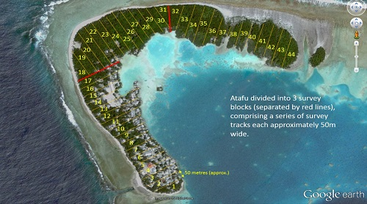  Atafu village motu divided into forty-four 50-metre-wide survey tracks for visual survey by a team of five surveyors (© Allan Burne, Pacific Biosecurity / Google Earth)
The tracks in the example are approximately 50 m wide and are placed so that they strand so onh from the lagoon side to the ocean side of the motu.
Having clear landmarks, or a consistent direction of travel (such as North to South to North) at the beginning and end of each track helps in navigation on the ground.
Each survey track is assigned a number for recording. It is important to record which survey track(s) invasive ants are seen in, in order to plan any treatment.
The tracks in the example are 50 m wide because they will be surveyed by five people (surveyors) spaced 10 m apart.  If fewer people are available, make the track narrower and have more of them.  So, if there are only three surveyors divide each block into tracks that are 30 m wide and once again space the surveyors at 10 m intervals. |  | 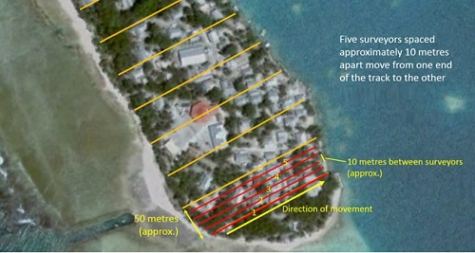  Five people, spaced approximately 10 m apart move from one end of the survey track to the other (red lines) looking for invasive ants (© Allan Burne, Pacific Biosecurity / Google Earth)
Conducting the survey
The surveyors move in a line parallel to each other from one end of the survey track to the other. Each surveyor checks the ground for the target ant species and checks any favoured places that may harbour ant nests.
The surveyors should generally be careful not to disturb any nest while searching as this may promote budding. An exception is for little fire ants (Wasmannia auropunctata). For these ants’ disturbance of the litter layer, soil or infrastructure at assessment points is considered good as it stimulates ant activity.
The surveyors should also check any nonu / noni or other fruit or flowers. Ants will likely be found foraging on them if they are present in the area. Similarly, any trees should be checked for ants trailing up and down them.  One surveyor needs to be responsible for recording where ants are observed on a record sheet, aerial image or map. The track number should be recorded, and where the ants were found. |  | 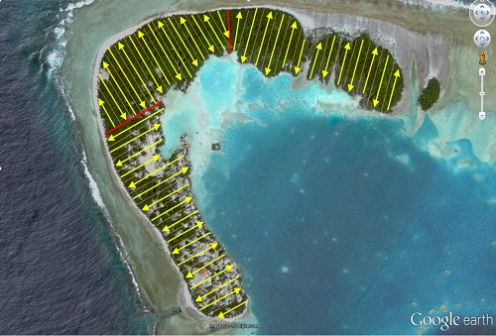  At the end of each survey track the team regroups spaced 10 m apart as before and proceeds with the survey moving in the opposite direction (© Allan Burne, Pacific Biosecurity / Google Earth)
If very few ants are found it would be helpful to mark the area for spot treatment.
The group moves back and forward throughout the survey area until it has been covered.
The surveyors move in a line through each survey block.
When the surveyors reach the end of the block, they move into the next block, turn 180° and move through the block in the opposite direction to the previous block.
Spacing is important  It is important to maintain good spacing, by ensuring the survey team are equally spaced and they cover the whole area. This can be achieved using the technique shown on the right. |  | 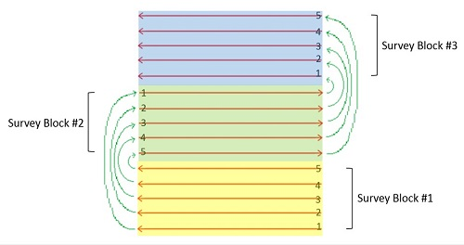  Five surveyors move from one end of each survey block to the other (© Allan Burne, Pacific Biosecurity)
When the survey team reach the end of a survey block (#1), the surveyor closest to the next un-surveyed block (surveyor #5) moves approximately 10 m toward the next survey area (survey block #2) and turns around 180° (such as if they were facing the ocean, they should now be facing the lagoon or vice versa).
The rest of the team space themselves out 10 m apart in the new survey track and continue the survey as before.
You can find more information about visual surveys in the Atafu Management Plan http://piat.org.nz/uploads/PIAT_content/pdfs/DRAFT%20Management%20plan%20for%20Atafu%20v11.pdf.
Recording data
Data from each survey track should be recorded in a table (example below also) with the track number, if the target species was seen, the number of times it was seen along the track, abundance, if lures were used, and location and general notes about the observations.
Track number | Target ant species | Present (Y/N) | Number of times seen on track | Abundance (at one spot) * | Lures used (Y/N) | Location notes | General notes
1 | Yellow crazy ant | N
2 | Yellow crazy ant | Y | 10 | H | N | high around the centre of the track | follow up with spot treatment of AntOff
and so on
*In this example for yellow crazy ants, abundance was measured using card counts. Low = 1-10 Medium = 11-29 High = More than 30
When no ants are detected during a visual survey, attractive lures should be used to confirm absence, as ants at low abundance can be difficult to detect with visual surveys alone.
SOURCES: Pacific Invasive Ant Toolkit: Visual surveys http://piat.org.nz/index.php?page=visual-surveys#surv

Attractive lures
Using lures for general surveillance
Routine use of non-toxic lures around surveillance areas (such as transport hubs, ports, airports) provides early warning of new incursions. This type of surveillance is used routinely by MPI in New Zealand as part of the National Invasive Ant Survey.
Over time this regular surveillance can build valuable information about different ant species’ rates of spread.
Ants are drawn to the lures, allowing them to be caught and identified. For a general surveillance campaign both protein and sugar lures are used, so it is important to note which sort of bait the ants were collected on in order to help formulate bait matrix composition for later management activity.
Where the objective is surveillance of a specific species, lures designed to attract just that species are needed. For example, little fire ants are best detected using peanut butter lures. Yellow crazy ants respond well to sweet lures such as honey or sugar water.
Materials
For luring you will need:
- sugar and water or honey or jam
- toilet paper or cotton wool (for sugar water or honey)
- card or paper to place the lures onto (or plastic jars if the ants are to be collected for identification)
- peanut butter or oily fish, sausage, pet food or other protein
- lollipop sticks, chopsticks or other sticks for peanut butter (for little fire ants)
- notebook and pen or pencil to record notes
- specimen jars, pottles or vials (if possible)
- GPS to record placement of lures (if possible)
Placing protein (fish or peanut butter or other) and carbohydrate (jam or liquid honey or 20% sugar water soaked cotton wool or toilet paper) lures in containers such as specimen jars, pottles or vials over the surveillance area gives an indication of presence or absence of ants.
Lures should be spaced approximately 10 m apart in groups of 10-20 extending approximately 500 m away from the centre of the surveillance area. In high risk areas the number of lures should be increased to at least 8 lures per 10 x 10 m area.  Attractive lures should be placed between 8am and 11am or between 3pm and 6pm when ants are likely to be more active. Do not place lures when rain is imminent. If it does rain during the period, the work will need to be repeated.  Mark where lures have been placed either on an aerial map/diagram or use GPS waypoints. If you are using a GPS, make sure the waypoint number corresponds with the number on the vial or pot. Upload the waypoints into Google maps for future reference. |  | 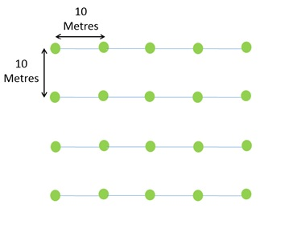  Placement of lures at 10m intervals in groups of 10 -20. The lures should be placed in areas that ants are likely to forage, such as shaded areas, around fruit trees or other potential food resources (© Allan Burne, Pacific Biosecurity)
The lures should be retrieved after three hours, labelled (location, bait type, date and time) and taken for identification of any ants captured. The ants should be placed into a preservative (70% ethanol or other alcohol or propylene glycol) to prevent them from rotting. The ants can also be frozen if they do not need to be sent away for identification.

Using lures for delimiting and monitoring
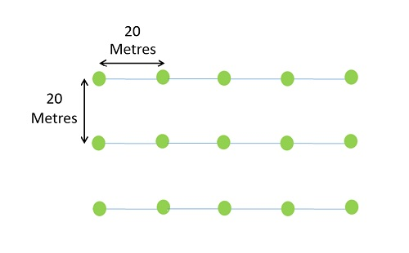  Where no ants are observed during a visual survey of a previously infested area, place attractive lures at 20m intervals (© Allan Burne, Pacific Biosecurity) |  | Lures should be used for delimiting and monitoring if possible. When a visual survey has been done as part of delimiting or monitoring, and no ants were detected, attractive lures should also be used to confirm their absence.  If the target species are present at low abundance, the lures will likely draw them to where they can be seen.  The lures (appropriate for the ant species being targeted) are placed on the ground at 20 metre intervals. This can also be checked by using food preference tests.
For delimiting it is best to place both protein and carbohydrate lures on cards or in pottles in the survey area.
Only a small amount of food is required per lure - about the size of a fingernail should be enough.
If the target ant species clearly recruit to one type of lure better than another it is safe to just use this type of lure. For example, yellow crazy ants often prefer sugar over protein, so only sugar lures need to be used.
Little fire ants are the opposite - they love peanut butter! The Hawai'i Ant Lab has easy instructions http://piat.org.nz/uploads/PIAT_content/pdfs/fact%20sheet%203%20-%20lfa%20survey.pdf on using chopsticks, popsicle sticks, or coffee stirrers with a very thin layer of peanut butter to detect little fire ants. You can paint the sticks a bright colour to make them easier to see. And the Hawai'i Departments of Agriculture (DOA) and Land & Natural Resources (DLNR) has produced a great video http://piat.org.nz/index.php?page=attractive-lures#lfa-home on how to check for little fire ants.
Placement of lures in visual survey tracks
Have a look at the information on visual surveys to check how the tracks are set up, and why five surveyors are referred to here.
Going back to the first survey track, lures should be placed by surveyors 1, 3 and 5 on their respective lines (below left). In the next adjacent survey track the lures should be placed by surveyors 2 and 4 (below right).
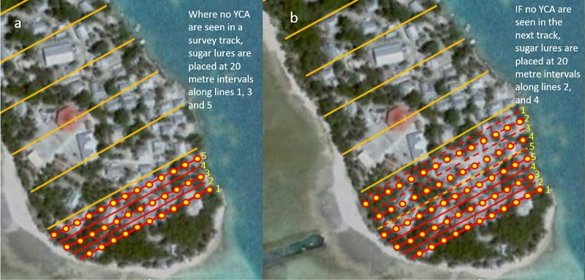
Sugar lures (yellow circles) are placed at 20 m intervals first by surveyors 1, 3 and 5 in the first track (a), then by surveyors 2 and 4 in the second track (b) (© Allan Burne, Pacific Biosecurity / Google Earth)
In the next track the lures are placed by surveyors 1, 3 and 5 again.
By repeating this pattern, you will create a matrix of lures spaced at 20 m intervals. Any ants present will be drawn to the lures, allowing them to be caught and identified.
For most ants attractive lures should be placed between 8am and 11am or between 3pm and 6pm when ants are likely to be active.
Do not place lures when rain is likely. If it does rain during the period, the work will need to be repeated.
Mark where lures have been placed either on an aerial map/diagram or use GPS waypoints. If using a GPS, make sure the waypoint number corresponds with the number marked on the map. Upload the waypoints into Google maps for future reference.
The lures should be checked after thirty minutes, and if no ants detected, checked again after three hours. Any target species found should be recorded.
Detecting little fire ants
This three-minute-long video provides step-by-step, easily understood instructions, on the simple procedure for testing for little fire ants.
The “How to Test for LFA” video http://piat.org.nz/index.php?page=attractive-lures#lfa-home was produced by DLNR in cooperation with DOA and other agencies that are jointly addressing the problems little fire ants cause in Hawai'i.
The method relies on the little fire ants love of peanut butter.
SOURCES:
Pacific Invasive Ant Toolkit: Attractive lures http://piat.org.nz/index.php?page=attractive-lures
Pacific Invasive Ant Toolkit: Active surveillance http://piat.org.nz/index.php?page=surveillance#act-surv
Pacific Invasive Ant Toolkit: Delimiting http://piat.org.nz/index.php?page=assessing-the-problem#delimiting
Pacific Invasive Ant Toolkit: Visual surveys http://piat.org.nz/index.php?page=visual-surveys

Passive surveillance
- Distribute awareness materials – see section 10.2.6
- Run regular public awareness campaigns
If possible, set up a reporting system as outlined in the Catch it early Battler Guide.
SOURCES:
Catch it early: invasive species early detection and rapid response. SPREP invasive species battler guide. 2016. SPREP. Apia, Samoa.

RESPOND
In this section:
- Identification
- Containment
- Delimiting
- Continued surveillance
- Treatment activities

Identification
Often, we are asked for an easy way to identify ants using colour and size. Unfortunately, there are so many small brown ants (for example) that it is very difficult to provide a simple key. With over 12,000 ant species, identifying them can be a tricky business. Some species are easy to identify, and some are more difficult. Correctly identifying your target species is the first step in planning an appropriate management response.
The PIAT gives a general description of the 5 worst threat ants of the Pacific, and another 13 common invasive ants in the Pacific to help you narrow down your search.
You can find out what other ant species may be in your area by looking on our Ants of the Pacific database. Knowing the ants already in your country can make identification much simpler.
We have also developed resin blocks, with the 5 worst invasive ants in the Pacific embedded in them as a reference. These are available for biosecurity / quarantine officers from SPREP / SPC / Pacific Biosecurity.
If you need help in identification, find out how to capture images and send samples to experts. As well as contacting individual experts, the Pacific Island Network for Taxonomy may be able to help.
The Pacific Invasive Ant Key
Arguably the best and most comprehensive online resource to help identify invasive ants in the Pacific is the Pacific Invasive Ant Key (PIAkey), which provides pictures and diagnostic characteristics for dozens of different invasive ants that have invaded the region (in the factsheets section).
Identifying ants from pictures can be difficult without a microscope. The PIAkey includes baiting videos of ant behaviour, which can really help in identifying them.
Behaviour can be an easy way to identify ants. For example, a small yellow ant falling from trees and stinging people is most certainly a little fire ant.
Note that the key to species section in the PIAkey only works for old Java / Firefox versions and will not work on Chrome browsers. However, the factsheets are very useful.
Although the PIAkey is an online tool, free CD copies can be ordered. Please contact Eli Sarnat regarding ordering.
By the same team that made the PIAKey, Antkey.org is also an excellent resource with a key (that works with all browsers and versions of Java) to over 100 species of exotic ants found worldwide.
Antkey is also available as a mobile app for Android and iOS.
A basic guide to identifying ants
By dividing animals into smaller and smaller groups based on physical characteristics that are exclusive to each group, we are able to identify them more efficiently than looking at an individual and asking, "what is this animal?". This is based on viewing all living things within a hierarchy like the image on the right.
The physical characteristics we use to identify animals (and all other living things) are known as morphological characters. For example, we can separate ants from every other type of animal on Earth in just five steps:
- Kingdom: Animalia – all the animals on earth
- Phylum: Arthropoda – are animals with an exoskeleton (external skeleton) and a segmented body, with paired jointed appendages (this group includes crabs, lobsters, spiders, centipedes, woodlice and insects)
- Class: Insecta – all insects have three body segments (head, thorax and abdomen) and 3 pairs of legs attached to the thorax (includes beetles, butterflies, grasshoppers, wasps, bees, ants and so on.)
- Order: Hymenoptera - have two pairs of wings joined by wing hooks. Only this order has this characteristic wing morphology (includes sawflies, woodwasps, wasps, bees and ants)
- Sub-Order (not shown on the right): Apocrita - all have a constricted joint between the thorax and abdomen known as a “wasp waist”. Only ants, wasps and bees are the animals to have this characteristic
- Family: Formicidae - all have a well-defined segment (the petiole) between the thorax (mesoma) and abdomen (also called the gaster in ants) and have “elbowed” antennae. Only ants have these characters.
From there we can use special features to identify the sub-family, then the genus and finally the exact species of ant. The genus and species identifiers are used to give the ant its scientific name. For example, the red imported fire ant's scientific name is Solenopsis invicta. Solenopsis is the genus and invicta is the species part of the name. This way we can also tell that the tropical fire ant (Solenopsis geminata) is closely related to the red imported fire ant (they are in the same genus). And these ants look very similar because they are closely related.
Key features used to identify ants
Ants are identified by experts using taxonomic keys that are based on characteristics (characters or features of those ants).
Identifying ants can be a complex problem as there are thousands of species of ants and sometimes only minor, microscopic features set them apart.
There are more than 12,000 species of ants worldwide. By grouping these species into sub-families, it becomes easier to identify them. There are 16 sub-families of ants, but only four of these sub-families are a concern in the Pacific:
- Myrmicinae
- Ponerinae
- Formicinae
- Dolichoderinae
Identifying a sub-family in 5 easy steps
The four ant sub-families found in the Pacific (Myrmicinae, Ponerinae, Formicinae, Dolichoderinae) can easily identified in a few short steps by looking at just a couple of characters (or body parts).
First it is important to know the names of these body parts or characters, which are shown in the diagram below. They key characters used to separate the sub-families of ants are the petiole and the gaster (particularly the pointy end, which has a sting, acidopore [hole to spray acid], or slit, depending on the sub-family). The petiole is the joint that separates the mesoma - which the legs are attached to - from the gaster (the abdomen). Ants have either one or two of these petiole segments.
You will need to use a microscope to see these features.
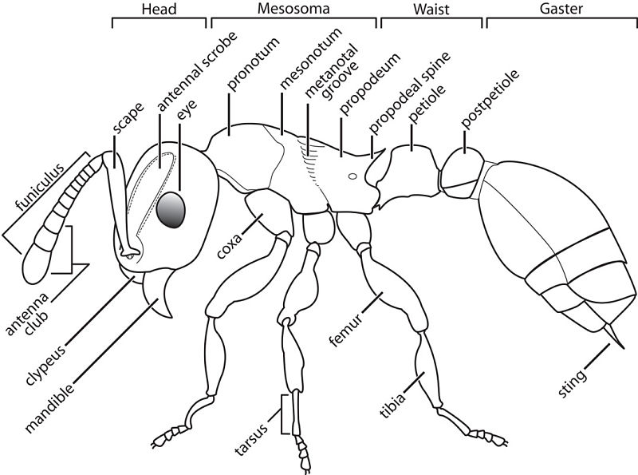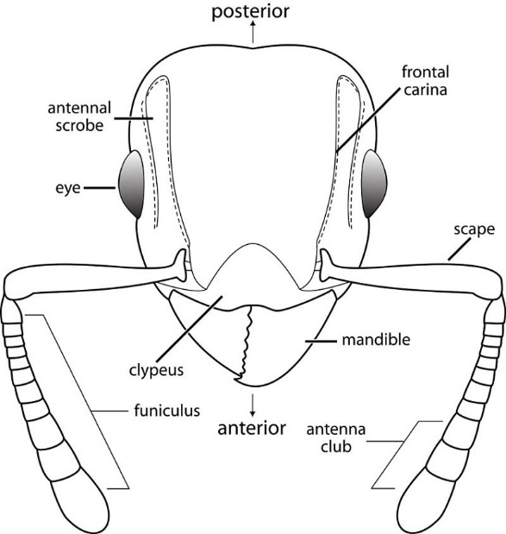
Left: Diagram showing the four main sections of an ant's body and anatomical features. Above: Diagram showing main features of the head. (© Eli Sarnat, Creative Commons Attribution, Share Alike CC BY-SA Licence)
Step 1.
Does the ant have one or two waist / petiole segments? Or is the waist / petiole flattened or hidden? See below for examples.
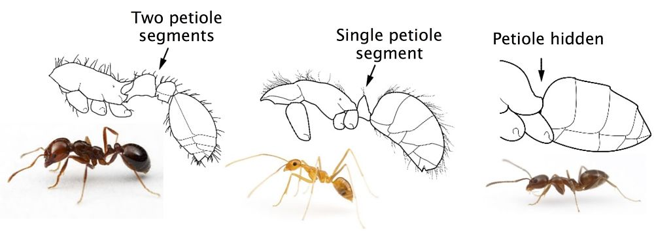
Line drawings © Eli Sarnat, Creative Commons Attribution, Share Alike CC BY-SA License; Photos © Alex Wild
If the Pacific Island ant you are looking at has two petiole segments, you know it is in the Myrmicinae sub-family (a myrmicine ant). Problem myrmicines in the Pacific include African big-headed ant (Pheidole megacephala), bicoloured pennant ant (Tetramorium bicarinatum), bicoloured trailing ant (Monomorium floricola), little fire ant (Wasmannia auropunctata), pharaoh ant (Monomorium pharaonis), red imported fire ant (Solenopsis invicta), similar groove-headed ant (Tetramorium simillimum), Singapore ant (Trichomyrmex destructor) and tropical fire ant (Solenopsis geminata).
Step 2.  If the ant only has only one waist / petiole segment, is it raised or hidden/flattened? See the image on the right for examples.  If the petiole is flattened or hidden it most likely belongs to the Dolichoderinae sub-family (a dolichoderine ant). | 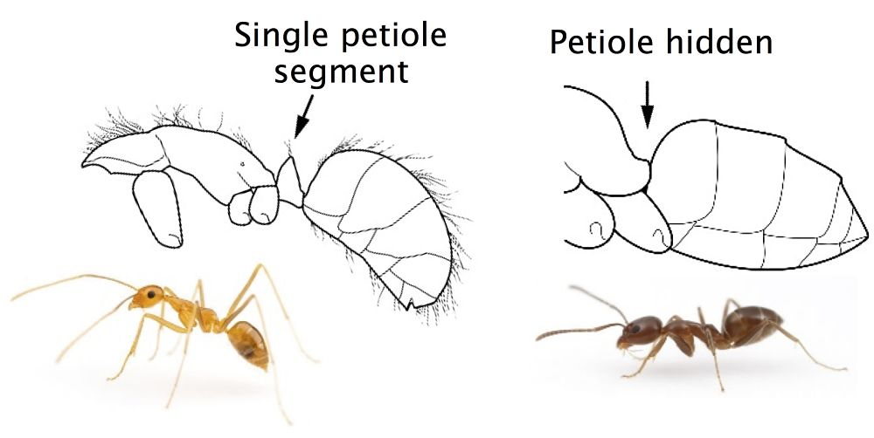  Line drawings © Eli Sarnat, Creative Commons Attribution, Share Alike CC BY-SA License; Photos © Alex Wild
Step 3.
Check to see that the end of the abdomen has no stinger or acidopore (hole) to confirm if it is a dolichoderine ant. Problem dolichoderine ants in the Pacific include Argentine ant (Linepithema humile), ghost ant (Tapinoma melanocephalum) and white-footed ants (Technomyrmex albipes, Technomyrmex difficilis, Technomyrmex vitiensis).
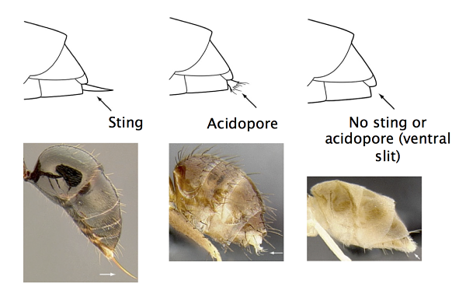
© Eli Sarnat, Creative Commons Attribution, Line drawings Attribution Non-Commercial CC-BY NC License; Photos Share Alike CC BY-SA License
Step 4.  If there is a single waist segment (petiole) and it is raised check to see if there is a pinched in constriction between the first and second segment of the abdomen.  If this constriction is present, check the end of the abdomen for a pronounced stinger.  If the ant has a stinger and pinched abdomen it is a ponerine ant (sub-family Ponerinae). |  | 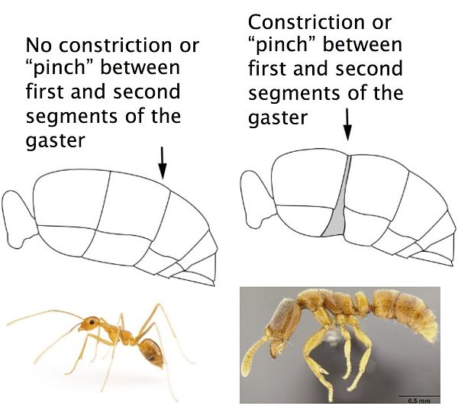
Left photo © Alex Wild; Right photo and line drawings © Eli Sarnat, Creative Commons Attribution, Share Alike CC BY-SA License
Ants from the Ponerinae sub-family are not a serious invasive threat in the Pacific.  However, some species, such as the trap-jaw ant, Odontomachus simillimus (left), can give a painful sting. |  | 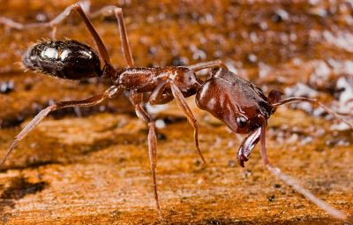  © Eli Sarnat, Creative Commons Attribution, Share Alike CC BY-SA License
Step 5.  If the waist / petiole is raised and there is no pinched abdomen check for the presence of an acidopore (left).  The acidopore is used to spray formic acid and gives the sub-family its name: Formicinae.  Problem formicine ants for the Pacific include yellow crazy ant (Anoplolepis gracilipes), black crazy ant (Paratrechina longicornis), browsing ant (Lepisiota frauenfeldi) and tawny crazy ant (Nylanderia fulva). |  |  |  | 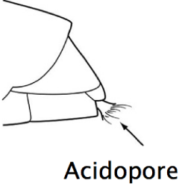  © Eli Sarnat, Creative Commons Attribution, Attribution Non-Commercial CC-BY NC License
Further identification
Once the sub-family has been identified other characters are used to identify species. We haven't included identification down to species level here, as the best resources for this are the PIAkey, Antkey and other resources are available.
Key characters to help determine the species include:
1. Presence or absence of hairs | 2. Length of the first antennal segment (called the scape) relative to the head
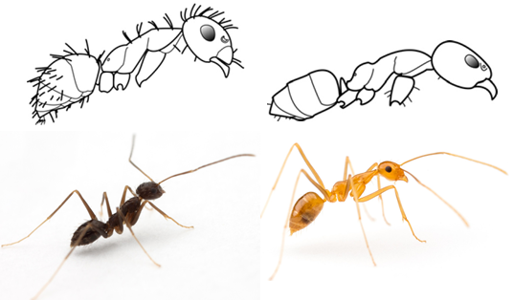  Drawings © Eli Sarnat. Photographs © Alex Wild | 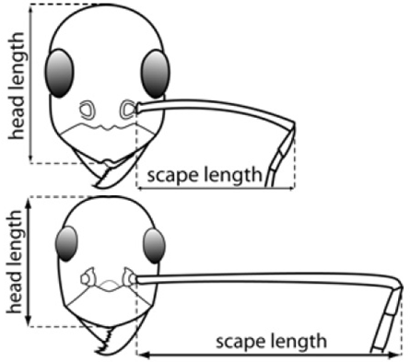
3. Presence or absence of propodeal spines on the rear end of the mesosoma
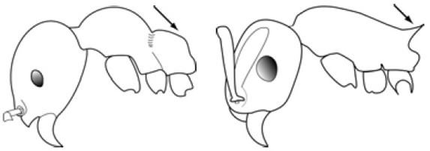
© Eli Sarnat
4. Presence and number of antennal clubs
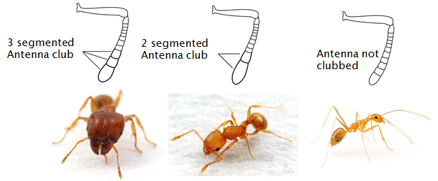
Drawings © Eli Sarnat. Photographs © Alex Wild
How to use a binocular or dissecting microscope
Place the microscope on a level bench and plug it into the nearest power supply.  Place the specimen you want to identify into a Petri dish that is partially filled with preservative and place it under the microscope.  There should be two light sources on the microscope. The top light shines down on the specimen. The bottom light shines from below the specimen.  Turn on the light(s).  You should be able to adjust the light to allow you to view the specimen lit only from above, only from below, or lit from both above and below. Decide which offers you the best view of the specimen. |  | 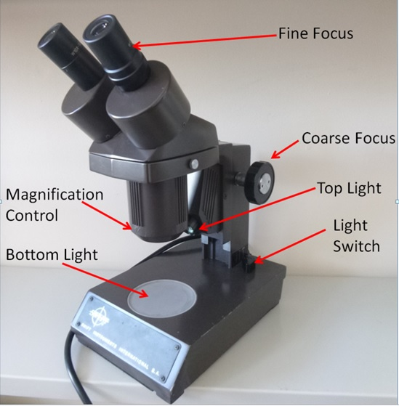  A standard binocular microscope with the main features labelled (© Allan Burne, Pacific Biosecurity)
Make sure the magnification control is set to the lowest setting. Close your left eye and look through the right eyepiece. Frame the specimen in the centre of the field of view.
The distance between the two eyepieces should be adjustable. Open your other eye and adjust the eyepieces until you can see a single image.
One of the eyepieces may have a fine focus on it. If none is present, there will be a fine focus dial on the coarse focus knob.
Close the eye that that is looking through the eyepiece with the fine focus (or if no fine focus is present on the eyepiece, close whichever eye you prefer) and use the coarse focus knob to bring the image into sharp focus for the other eye.
Once the image is in focus close the eye you just had open and look through the other eye. Use the fine focus adjustment to bring the image into sharp focus for that eye. The microscope should now be adjusted for your eyes.
You may now adjust the magnification control to increase the magnification enough to observe fine details on the insect.
Additional resources for identification
There are a number of resources available online to help you identify ants. This workshop manual http://piat.org.nz/uploads/PIAT_content/pdfs/PIA_taxonomy%20workshop.pdf (download 4 MB) from the Pacific Invasive Ants Taxonomy Workshop is based on the PIAkey.
For a more technical identification key for those that are familiar with ant identification, E.O. Wilson and R.W. Taylor published The Ants of Polynesia http://piat.org.nz/uploads/PIAT_content/pdfs/ants%20of%20polynesia.pdf (download 10 MB), which provides a taxonomic key for identifying many native and introduced ant species in the Pacific.
This key to the ants of Micronesia http://piat.org.nz/uploads/PIAT_content/pdfs/Micronesia%20ant%20key.pdf (download 3 MB) may also be helpful, as could be the key to common pest ants of Malaysia http://www.chowyang.com/uploads/2/4/3/5/24359966/037.pdf (note that the identification of red imported fire ant being present in Malaysia is incorrect). For those trying to identify invasive ants from North America, identification and habits of major ant pests in the Pacific Northwest http://piat.org.nz/uploads/PIAT_content/pdfs/Ant%20pests%20of%20Pacific%20Northwest%20key.pdf (download 4 MB) may be useful.
If you are having trouble with identification, consider contacting someone with expertise in identification.
Genetic testing of red imported fire ants
If red imported fire ants are found, a sample of the ants should be sent for genetic testing. This is useful as the red imported fire ant has two social forms.
One social form (called monogyne – meaning ‘single queen’) disperses by flying and can travel up to five kilometres or more before starting a new nest. The other social form (called polygyne – meaning ‘many queens’) disperses by walking and new nests are found relatively close to the original nest. The two forms are identical in appearance.
If the monogyne form is detected, delimiting and monitoring must take into account the greater distance that can be travelled.
Chemical identification of fire ants
Red imported fire ants and tropical fire ants are just two species of ants in a larger group of fire ants.
It is important to know the difference as red imported fire ants cause such major problems, while most of the other fire ant species do not.
Different fire ant species are very difficult to tell apart using their physical features. However, fire ants sting venom (a chemical poison) differs between species so that is one way to tell them apart.
Until recently this been a very specialised method only done by scientists.
USDA scientists have now developed a kit that can identify the red imported fire ant by detecting the specific venom of the ant. The kit uses an on-the-spot test that requires no specialized training and takes just 10 minutes to complete.
The kit is now being further developed so that it can be mass produced.
SOURCES:
Pacific Invasive Ant Toolkit: Identification http://piat.org.nz/index.php?page=identification
For assistance with ant identification contact an expert listed in the PIAT: http://piat.org.nz/getting-help/technical-experts.
Some countries in the Pacific (Fiji, Samoa, Solomon Islands, Tonga, Tuvalu, Vanuatu) have access to the Remote Diagnostic facility: https://piat.org.nz/index.php?page=remote-diagnostic-facility

Containment
Movement controls
Movement controls are used to contain an incursion and prevent invasive species spreading from an infested area.
There are two parts to the containment of ants:
- Restriction of natural spread - preventing ants that have spread to a new area independently (by flight or on foot) from spreading to new areas by removing potential nesting sites and buffer clearance
- Reducing the risk of jump dispersal - ensuring invasive ants are unable to " hitchhike" out of the infested area and establish elsewhere
Both parts involve surveillance. In particular high value areas should be identified and secured.
Restriction of natural spread
Ants typically spread:
- when reproductive females (queens) and males leave the nest in a large group, mate and the mated queens fly to a new location to start a new nest.
- when mated queens ”bud” from their parent nest and walk with a group of workers to form a new nest nearby. This is the way most invasive ants spread naturally.
The most effective way to prevent this natural spread is by a combination of treatment of potential nesting sites, and buffer clearance.
Treatment barriers
Treatment barriers are created by prophylactic baiting using granular, paste or liquid baits complemented by residual sprays. These baits are placed within the infested area and in a buffer zone surrounding it. The radius of the buffer zone is dependent on the ant species present, but a minimum of 50 metres is recommended.
Some treatment examples include:
- Granular baits: Antoff® (fipronil based), Amdro® and Maxforce® Complete (hydramethylnon based), Siesta® (metaflumizone based). These baits are spread using a manual spreader within the infested area.
- Paste baits: Xstinquish® and Vanquish® Pro (Fipronil based). These baits are applied to cracks and crevices in the infested area and in the surrounding buffer zone.
- Liquid baits (for bait stations): Exterm-an ant® (Boric Acid based). These baits are placed inside the infested area at regular intervals and in the surrounding buffer zone.

- Residual sprays: Termidor® (fipronil based), Arilon® (indoxacrb based), Deltaforce® (deltamethrin based), Biff® ant, MAXTHOR® and Recruit® (all bifenthrin based). These sprays are applied in the infested area and surrounding buffer zone. The toxicant remains active for a period of several weeks.
Check the treatment options for the most appropriate products for different types of ants.
Buffer clearance
Ensure the area surrounding the infestation (buffer zone) is free from potential nesting sites such as piles of rubbish, stacked timber or disused machinery. Such sites, should be treated with granular bait, paste bait or residual insecticide before movement. After treatment, any materials to be removed from the surrounding area, must first be thoroughly searched by a biosecurity officer for any surviving invasive ants.
Reduce the risk of jump dispersal
The greater risk of spreading ants is via jump-dispersal associated with human transport. The first step required for reducing the risk of jump-dispersal is the identification of the high-risk pathways for transporting ants out of infested areas. Any goods, vehicles or machinery that could harbour invasive ants that are moved from the infested area represent potential pathways for the spread of ants.
You will need to know the answers to the questions:
- What is stored in the area?
- Are there any goods in the area that are routinely moved to other locations (such as building supplies, produce, potted plants and so on.)?
- Are there vehicles that are parked for long periods of time that are moved occasionally (tractors, boats on trailers, concrete mixers, and so on.)?
- It is essential that everyone that lives or works in the infested area is made aware of the ant’s presence, informed how the ants spread and required by law to either not remove any materials from the infested area or to submit any materials due for removal from the area for inspection by a biosecurity officer before they may be moved.
The United States Department of Agriculture has federal regulations for transporting high-risk goods from red imported fire ant quarantine areas to different states.
Identify and secure high value areas
When issuing any clearance to move checked items from a high risk (infested) area, it is also important to impose restrictions on where those items can be transported to.
No movement should be allowed into areas designated as high value, such as wildlife reserves, food storage areas, crop areas or populated areas where ants are likely to establish and cause environmental, agricultural or social problems.
A number of conservation groups implement special measures to ensure invasive species do not invade high value areas.
The State of Hawaii, Department of Land and Natural Resources has a video on Biosecurity protocols for protecting the northwestern Hawaiian islands. https://www.youtube.com/watch?v=1Yg2mSjuQmI
Tiritiri Matangi Island Sanctuary uses a warrant (http://piat.org.nz/uploads/PIAT_content/pdfs/pest%20free%20warrant%20brochure%20dec%202015%20web.pdf © Crown, CC BY 3.0 NZ) to ensure all tourism operators meet minimum standards to operate, and uses posters (http://piat.org.nz/uploads/PIAT_content/pdfs/Tiri%20biosecurity%20Poster%20SMALL.pdf © Crown, CC BY 3.0 NZ) to inform visitors of biosecurity risks from the mainland.

Delimiting
Delimiting uses the same protocols as surveillance but is conducted in a grid radiating out from the detection. A buffer with a radius of 1 km from the detected nest should be checked.
See section 10.3.1 for methods.
If the infestation was detected away from the EDDRRP area, or in a ‘secondary’ site i.e., not at a primary port, track back to source if possible.

Continued surveillance
See section 10.3.1 for methods.

Red imported fire ants
If red imported fire ants are detected (or suspected) “sentinel” stations at a radius five kilometres from the initial / previous detections should also be checked in case the monogyne social form is present.
The ants should also be sent for genetic testing.

Treatment activities

Notify public and stakeholders
Communication is important!
When undertaking treatment, it is essential that all stakeholders are kept informed of what is happening. This will minimise the risk of health effects and will also make the operations go smoothly.
If the treatment is happening in an inhabited area, communication should include public meetings, school visits, warning posters in and around the treatment area, warning leaflets for each household and health surveys for each household.
Posters and leaflets should feature the following information:
- The name of the chemicals being used
- When it is being used (dates from to)
- A photograph of the bait(s)
- Safety instructions (do not touch bait, watch children at all times and keep them out of the area, do not eat animals from this area and so on.)
- Contact details for further information
SOURCES:
Pacific Invasive Ant Toolkit: Applying treatments http://piat.org.nz/index.php?page=management

Monitoring
Monitoring is undertaken for three purposes:
- Evaluating treatment success: to evaluate the success of the treatments, monitoring of ant distributions and abundance is needed before and after treatment
- Evaluating if treatment is required: if treatment is not warranted because impacts are low or the problem is not urgent, monitoring of ant distributions and abundances is needed to assess if treatment should take place
- Monitoring non-target effects: to assess potential non-target effects of treatment, monitoring of local wildlife is needed before and after treatment, including measuring any potential effects of the pesticide on people
We have created a video https://www.youtube.com/watch?v=xYNC4sER1vc that outlines the methods of monitoring for invasive ants, using yellow crazy ants as a case study. The video is also available in French https://www.youtube.com/watch?v=C9S8-KJKhmE.

1. Evaluating treatment success
Before and after each round of treatment, ant abundance and distribution and impacts should be assessed in the same way as for delimiting and assessing impacts.
Multiple sites should be chosen in the treatment area and visual surveys (at a minimum) should be done. If time, resources and funding permit, other assessments can also be done, such as card counts (for yellow crazy ants), pitfall trapping (for ants and other insects) and luring.

2. Evaluating if treatment is required (not applicable to EDRR)
Many factors contribute to decisions to undertake treatment of invasive ants. If the ant is one of the "worst five", it is best to consider treatment a high priority. However, if people are not being affected by the ants, there might not be much support for using pesticides.
Even if treatment is not considered a high priority, the situation should still be regularly monitored so that any worsening effects can be detected. The frequency of monitoring will depend on the time, resources and funding available. Ideally, ant monitoring should be undertaken at least every 6 months.
During each monitoring event, ant abundance, distribution and impact should be assessed in the same way as for delimiting and assessing impacts. One additional requirement is that areas outside the infestation need to be monitored in case the ant spreads.
One cost-effective way to have the monitoring done is to enlist the community to help. This also has the benefit of raising awareness and creating support to undertake treatment.

3. Monitoring non-target effects
Monitoring for non-target effects requires planning well before treatment is undertaken. Environmental impact assessment is needed to identify any possible non-target effects.
We have provided a range of suggestions for monitoring, but what is monitored will depend on the ecological conditions at the treatment site, the species of conservation concern that are present, the budget available for monitoring, and whether people are likely to be affected. Very few studies monitor pesticide residues, which is an area of ant control that requires further study.
SOURCES:
Pacific Invasive Ant Toolkit: Monitoring http://piat.org.nz/index.php?page=monitoring
Pacific Invasive Ant Toolkit: Management Plan for Atafu Tokelau. https://piat.org.nz/uploads/PIAT_content/pdfs/DRAFT%20Management%20plan%20for%20Atafu%20v11.pdf

Undertake treatments
Health and safety
When handling and distributing pesticides, health and safety is the primary concern. EVERY chemical that is used for ant control will have an accompanying Safety Data Sheet (SDS). SDSs for all products are available online or you can request a copy from the supplier of the bait or pesticide you plan to use. Some basic rules of safe handling include:
- Always read the instructions before use
- Use gloves when handling products (check the SDS for details of which type of gloves offer the best protection and other personal protection recommendations)
- Do not eat, drink or smoke whilst handling pesticides
- Always wash your hands after using any chemicals
- Avoid breathing any vapours or dust - wear appropriate respiratory protection if necessary
- Store all insecticides in a secure place away from children and animals
- Ensure all stakeholders are made aware of any risks associated with insecticide use
Treatment application
Instructions on the use of granular baits, targeted insecticides, paste and gel baits, bait stations and nest injection are provided here. We show you details of how to measure and spread bait efficiently, how to look for non-target effects and case studies of ant management programmes that have been successfully undertaken in a variety of environments.
Treatment products can be obtained from a number of suppliers. http://piat.org.nz/index.php?page=how-much-will-it-cost#suppliers
Ant baits are expensive and can have non-target effects on the environment. For these reasons it is important to distribute the correct amount of bait in the right way - too little and you will not achieve your goals, too much and the bait will remain in the environment where it might poison beneficial organisms or contaminate ground water. Also use the correct treatment for your target species and environment.
When applying any insecticide or other bait it is essential that you:
- read the manufacturer's instructions and observe correct application rates
- read the Safety Data Sheet (SDS) for the product and wear the appropriate personal protective equipment
- read the Environmental Impact Assessment for the activity and observe all precautions to prevent non target effects or accidental contamination of the environment
We have created a video that outlines the methods of application for the three main manual treatment options: granular broadcast baits, bait paste and residual sprays. http://piat.org.nz/uploads/PIAT_content/videos/Treatment%20methods%20for%20ants%20-%20YouTube%20[360p].mp4.
SOURCES:
Pacific Invasive Ant Toolkit: Applying treatments http://piat.org.nz/index.php?page=management
Pacific Invasive Ant Toolkit: Methods of application (video) http://piat.org.nz/uploads/PIAT_content/videos/Treatment%20methods%20for%20ants%20-%20YouTube%20%5b360p%5d.mp4
Pacific Invasive Ant Toolkit: Granular baits http://piat.org.nz/index.php?page=granular-baits
Pacific Invasive Ant Toolkit: Paste and gel baits http://piat.org.nz/index.php?page=paste-baits
Pacific Invasive Ant Toolkit: Targeted insecticides http://piat.org.nz/index.php?page=targeted-insecticide

Vectors and pathways are terms used to describe how pests and diseases get from place to place (or person to person). The terms are used frequently in a biosecurity context, but sometimes with different meanings to different people. Here, we've used both terms in the tables as some of the ways described are considered to be vectors, and some are pathways (although people might define them differently).

