Tetiaroa atoll ant survey – October 2016

Report prepared by Monica Gruber
Version 2: January 9 2017
Survey by Dr James Russell¹, Dr Araceli Samaniego-Herrera², Dr Herve Jourdan³, Dr Monica Gruber⁴
Identifications by Dr Herve Jourdan³, Dr Meghan Cooling⁴
1 University of Auckland
2 Pacific Invasives Initiative
3 Institut Méditerranéen de Biodiversité et d'Ecologie Marine et Continentale
4 Pacific Biosecurity, Victoria University of Wellington
The goals of the ant work were to: 1) survey Tetiaroa ant fauna with a specific focus on identifying any problem invasive species, and recommend any applicable actions; 2) identify areas where biosecurity against invasive ants could be improved – primarily because little fire ants Wasmannia auropunctata are present in Tahiti, which is the main entry point to Tetiaroa. After we arrived we were asked to provide advice on dealing with the Brando management concerns regarding ants in and around guest villas and around the villa pools and main pool.

Why do we care about invasive ants?
An invasive ant is an ant species that is outside its home range (introduced) and damages the human or natural environment. There are many introduced ant species in the Pacific region, most of which are harmless to people, agriculture and the environment. However, a number of very invasive ant species can cause serious harm.
Part of the reason these invasive ants are such a problem is the incredibly high numbers they can reach. When invasive ants reach high abundances, they cause harm in three ways:
- Agriculture: the ants "farm" scale insects, aphids and other sap-sucking bugs, which damage crop plants, reduce yields and spread crop diseases
- Environment: they can kill or injure local wildlife including birds, crabs, lizards, insects and make it difficult for stock animals like pigs and chickens to feed
- Society and Culture: many invasive ants sting, bite or spray acid when disturbed. Stings can form blisters and become infected. Even if they don't sting or bite ants can be in such high numbers that people cannot eat, work or sleep because there are always ants crawling all over them.
The 5 worst invasive ant species include the yellow crazy ant (Anoplolepis gracilipes), the red imported fire ant (Solenopsis invicta), the African big-headed ant (Pheidole megacephala), the little fire ant (Wasmannia auropunctata) and the Argentine ant (Linepithema humile). These five species are on the International Union for the Conservation for Nature's 100 of the world’s worst invasive alien species list due to the damage they can cause, and their worldwide distributions. These are also the ants that are most commonly targeted in management programmes, because of the problems they cause.
Ants live in colonies, which might be made up of a single nest with one queen, or as is the case with most invasive ants, many nests each with many queens. There are three types of ants: queens, workers and males. Queens are responsible for all reproduction in the colony, and starting new colonies. The males live only to mate with new queens and die shortly thereafter.
The workers, which are all female, are (typically) sterile and responsible for taking care of the brood (eggs, larvae and pupae), tending to the queen or queens, foraging for food and colony defence. Workers are the ants you are the most likely to see.
As all the reproduction in the colony is done by the queen, any management method has to kill the queen (and usually invasive ants have many queens). Not only that, for some invasive ants it only takes one queen (or even one queen pupa) to start a new colony. This makes it very difficult, but not impossible, to detect and control invasive ants. However, large infestations require a significant effort and cost to control and even small infestations require more effort to be eradicated than other invasive species. This is why biosecurity measures that specifically deal with invasive ant risks are so important.
For more information on invasive ants, their biology and their impacts, please visit the Pacific Invasive Ant Toolkit website http://piat.org.nz/problem-ants.

Tetiaroa ant fauna
We identified a total of 23 ant species on Tetiaroa atoll (Table 1). Unsurprisingly Onetahi, the only currently inhabited motu, had the greatest species richness (n=16). Other frequently visited islands also had relatively high species richness (Rimatu’u n=12; Honuea n=11).
Of the invasive ants of most concern in the Pacific we detected the yellow crazy ant Anoplolepis gracilipes (Onetahi and Oroatera), and the African big-headed ant Pheidole megacephala (Onetahi, Honuea, Rimatu’u, Tahuna iti, Tauini, Tiaraunu). Of note is that we did not detect little fire ant (Wasmannia auropunctata) which is found on Tahiti.

Yellow crazy ants on Onetahi are patchily distributed throughout the centre of the motu (right).
The area infested extends approximately from the service area behind villa 106 and the tennis court northward along the staff road towards the staff quarters (but not sighted around the staff quarters), in the composting areas and gardens along the staff road, and at the airstrip arrivals area among the plantings there).
Yellow crazy ants were first recorded from Onetahi by Elin Claridge in 2007 around similar areas and also observed by James Russell in 2009 along the north-eastern coast.
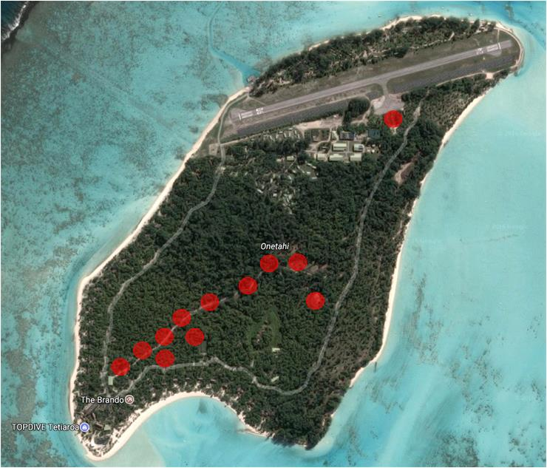

Erin Claridge also surveyed Honuea and Tiaraunu. Although she reported detecting yellow crazy ants on all three motu, we consider this was an error in her report, as her GPS detection points for yellow crazy ants omit Honuea and Tiaraunu, and the method she used on these motu was sweep netting: a method that is unlikely to detect ants.

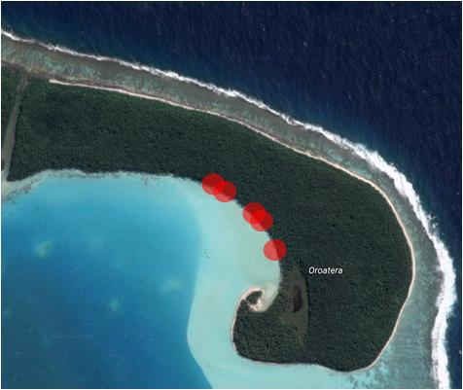
Prior to our visit yellow crazy ants had not been detected on Oroatera. We detected the ants on the lagoon side (left) to which our search was limited. Although we did not have sufficient time to delimit the infestation the ants are likely to be patchily distributed throughout more of Oroatera motu than we surveyed.
It is difficult to know whether the Oroatera invasion is recent, as this is the first time to our knowledge that this motu has been surveyed for ants.
Although the yellow crazy ant queens have wings, it is thought that yellow crazy ants do not disperse by flying

Typically these ants disperse by hitchhiking on goods, plants, produce etc. It is worth noting that Oroatera is used as a picnic destination and the detections are not far from this area, so this could have been how the ants arrived. Alternatively they may have arrived with other expeditions, such as recent research at this location by. However, we can only speculate on the means of arrival, as we do not know what items people are transporting between motu.
Although yellow crazy ants are already present on Tetiaroa, new infestations should be prevented. Yellow crazy ants appear to sometimes undergo rapid population expansion shortly after arrival, with devastating effects: https://www.youtube.com/watch?v=u39C-FSkdIc (French) and https://www.youtube.com/watch?v=VBhUSLdvFfw (English).
The distribution of the African big-headed ants on Tetiaroa is much more widespread than yellow crazy ants, and these ants are common throughout the Pacific. These ants can cause serious problems for nesting seabirds when they reach high abundance, but often have little effect on people or the environment.
The yellow crazy ant and African big-headed ant currently do not appear to be having any detrimental effects on the motu they inhabit in Tetiaroa. However, they are both known to increase to high abundance which results in negative effects on the environment (e.g. nesting sea birds, crab fauna) and human well-being (see http://piat.org.nz/problem-ants for further information). We recommend the status of these two species be monitored as both ants are known to have outbreaks elsewhere that result in serious environmental and social impacts. These outbreaks are often driven by ant mutualisms with sap sucking insects such as scale, aphids and mealybugs. We detected some of these species, which the ants were tending, but not to such a level where this was yet likely to cause problems.

 | Onetahi | Honuea | Tiaraunu | Tauini | Auroa | Hira anae | Oroatera | Aie | Tahuna rahi | Reiono | Tahuna iti | Rimatuu | # motu occupied
Anoplolepis gracilipes | x |  |  |  |  |  | x |  |  |  |  |  | 2
Cardiocondyla emeryi | x |  |  |  |  |  |  |  |  |  |  | x | 2
Cardiocondyla minutior | x |  |  |  |  |  |  |  |  |  |  |  | 1
Iridomyrmex anceps grp | x | x | x |  |  |  |  |  | x |  | x | x | 6
Monomorium floricola | x | x | x |  |  | x |  |  |  | x | x | x | 7
Monomorium liliuokalanii | x | x |  |  |  |  |  |  |  |  |  |  | 2
Paratrechina bourbonica | x | x | x | x | x | x | x | x | x | x | x | x | 12
Paratrechina vaga | x | x |  |  |  | x |  |  | x | x |  |  | 5
Paratrechina longicornis | x |  | x |  |  | x | X |  |  |  |  | x | 5
Pheidole fervens |  |  |  |  |  | x |  |  |  | x | x |  | 3
Pheidole megacephala | x |  | x | x |  |  |  |  |  |  | x | x | 5
Pheidole oceanica | x | x | x | x | x | x | x |  |  | x |  | x | 9
Pheidole umbonata | x | x | x |  | x | x | x |  |  | x | x | x | 9
Ponera tenuis |  |  |  |  | x |  |  |  |  |  |  | x | 2
Solenopsis sp. | x |  |  |  |  |  |  |  |  |  |  |  | 1
Strumigenys membranifera |  | x |  |  |  |  |  |  |  |  |  |  | 1
Syllophopsis australica |  | x |  |  |  |  |  |  |  |  |  |  | 1
Tapinoma melanocephalum | x | x |  | x |  | x | x | x | x | x | x | x | 10
Tetramorium bicarinatum | x | x |  |  |  | x |  | x |  | x | x | x | 7
near Tetramorium simillimum | x |  |  |  | x |  | x | x | x | x | x | x | 8
Trichomyrmex destructor |  |  |  | x |  |  |  |  |  |  |  |  | 1
species richness per motu | 16 | 11 | 7 | 5 | 5 | 9 | 7 | 4 | 5 | 9 | 9 | 12

Biosecurity notes
We did not carry out a full biosecurity assessment of the atoll but made observations as we undertook our surveys.

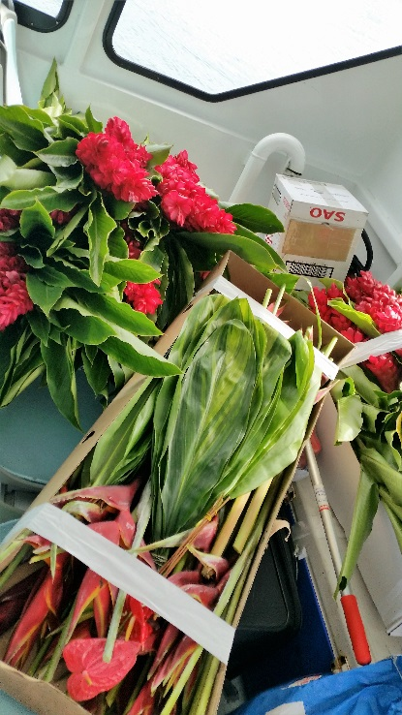
We noted that flowers were being transported from Tahiti on the staff boat without any apparent biosecurity measures (left).
Ants typically live in nests in the ground, and in trees. However, they can also nest in things like decaying coconuts, and little fire ants can nest in places as small as macadamia nuts, and complex flowers such as Heliconia sp.
The main way that little fire ant nests are transported from site to site is through potted plants. When the ants arrive in a new area, they start new nests in the new environment and the ants spread.
Thus, importing plants and flowers pose a direct threat as they can host ant nests e.g. potted plants and complex flowers.
Heliconia sp. flowers are commonly used for decorative displays in the Pacific and we observed these being sold at the market in Tahiti (below – the buckets contain Heliconia sp.).
We noted plants that are clearly not native to Tetiaroa on Onetahi (e.g. succulents in the staff gardens), and trust that anyone bringing plants from elsewhere in French Polynesia ensure these imports are from areas free of little fire ant.
Plant imports also pose an indirect threat as they can host the sap-sucking insects that drive ant invasion dynamics elsewhere (see http://piat.org.nz/problem-ants/characteristics-of-invasive-ants/sugar-devils for examples). On the staff boat from Tahiti to Tetiaroa we detected 6 species of ant [Herve has this list], some of which are not present on Tetiaroa [Herve to confirm], which highlights the potential for invasion. These ants were found on the flowers being imported from Tahiti.

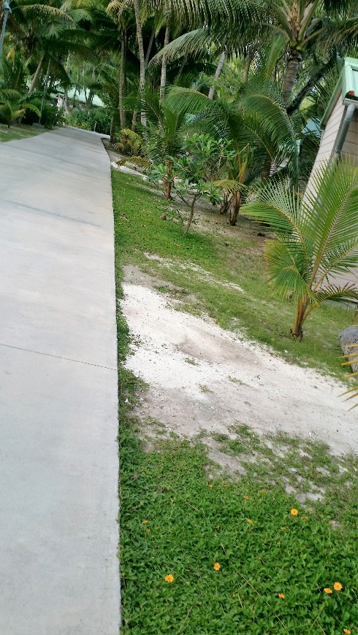
We noted that the Singapore daisy plant Wedelia sp. is common around the staff road in Onetahi (left).
This is a serious weed threat in the Pacific. As a ground cover it suppresses native vegetation and easily spreads via small fragments.
We recommend that this species be eradicated to remove the risk of spreading to the other motu. Advice on how to best manage Singapore daisy can be obtained from David Moverley, Invasive Species Adviser at SPREP (davidm@sprep.org).
After we arrived the Brando resort management asked for advice on how to respond to complaints from guests of ants in the villas and around pools.
The ants we found infesting the villas are ghost ants (Tapinoma melanocephalum) a common introduced species in the Pacific that is often found in kitchens and bathrooms, and is considered a pest by many people.

The pools areas were infested by ants from the taxonomically ill-defined Iridomyrmex anceps group and vague crazy ant / wandering crazy ant Nylanderia vaga, both relatively common introduced ants that, like ghost ants, are not known to cause any harm, although they can be nuisance species at times.
The hotel has been using Fourmidor®, which contains fipronil, as an ant treatment. Although this can be an effective treatment, fipronil based products are not recommended for extended ongoing use in atoll environments due to a number of environmental concerns. Fipronil is highly toxic to fish and aquatic invertebrates and is particularly hazardous in lagoons. In addition, the environmental fate of fipronil is not very well known, and it is potentially highly persistent in the environment. On Onetahi the toxin is also apparently not having the desired effect, so alternatives should be considered. See Appendix 2 for suggested alternative treatment options.

Recommendations
As a result of our survey of ants of Tetiaroa atoll we recommend:
- Improvements to biosecurity:
  - Enhancing greater awareness among Brando resort management and staff of what risk items are being imported, and the consequences of ant invasions (e.g. yellow crazy ants https://www.youtube.com/watch?v=u39C-FSkdIc (French) and https://www.youtube.com/watch?v=VBhUSLdvFfw (English) and little fire ants https://www.youtube.com/watch?v=mJ8TQ_ASsYQ (English only))
  - Managing and mitigating risk by ensuring plant imports are obtained from areas free of little fire ants and yellow crazy ants
  - Treating of flowers and plants by immersing in water during the boat journey or refrigeration for 24 hours prior to transport
  - Improve internal biosecurity by checking what is being transported between motu for risk items to stop ants spreading further
- Monitoring yellow crazy ant infestations
  - Spatially delimiting the infestations on Onetahi and Oroatera. Full protocols on monitoring can be found at http://piat.org.nz/assessing-the-problem.
  - Monitoring and updating the known spatial extent of the infestations every 6 – 12 months using the above protocols
  - Monitoring the abundance of yellow crazy ant infestations every 6 – 12 months and take action if yellow crazy ant population levels increase. Please see: http://piat.org.nz/assessing-the-problem/card-counts for information on monitoring yellow crazy ant abundance
- Changing the treatment methods for ants in the resort area (see Appendix 2)

Acknowledgements
Tetiaroa Society staff kindly supported the logistics for this survey. The work was funded by the Tetiaroa Society and University of Auckland. Many thanks to Dr Dave Nendick of New Zealand Ministry of Primary Industries for the detailed protocols for Brigade® / Biflex®.

Appendix 1: Methods
We surveyed all the motu of Tetiaroa between 7 and 15 October.
Ants were collected using three methods:
- Visual surveys of ants were undertaken on all motu (by Herve Jourdan and / or Monica Gruber), by inspecting likely nesting and foraging sites of ants.
- Peanut butter and sucrose lures (3-10 per motu depending on size) were placed on all motu where time permitted (i.e. excluding Tiaraunu, Tauini, Auroa, Hiraanae, Oroatera and Tahuna rahi).
- Pitfall traps (50ml specimen jars 1/2 filled with propylene glycol as a preservative) were placed on all motu according to motu size and usage by people (N=76): Onetahi (n=18 [17]); Honuea (n=7); Tiaraunu (n=14 [10]); Tauini (n=3 [1]); Auroa (n=3); Hira anae (n=3); Oroatera (n=4); Aie (n=4); Tahuna iti (n=6; Rimatuu (n=12); Tahuna rahi (n=3) and Reiono (n=6 [5]). The traps were left for 48 hours prior to identification of ants to species. In some cases crabs and rats destroyed the traps. The numbers in square brackets indicated the number of traps recovered in these cases.

Appendix 2: Suggested protocols for alleviating ant problems at the hotel
The hotel has been using Fourmidor®, which contains fipronil, as an ant treatment. Although this is an effective treatment, fipronil is not recommended for extended use in atoll environments because: a) long term fate of the toxin is unknown; b) metabolite products are known to be more toxic than the original fipronil compound; c) fipronil is known to be lethal to fish, marine invertebrates, all insects and bees in particular. Other alternatives are available and should be considered. These are provided as suggested options.

Option 1: Raising awareness
Although most ants in the Pacific are introduced they are a natural part of the environment. The vast majority offer no threat to the environment or human health and well-being. The ants around the villas and pool – ghost ants Tapinoma melanocephalum, ants from the Iridomyrmex anceps group and vague crazy ant / wandering crazy ant Nylanderia vaga – are not ranked highly among the invasive species in the Pacific, although they are a common nuisance species in the absence of more serious invasive ants.

Option 2: Regular treatment of surfaces in problem areas
This protocol is recommended as it uses effective methods recommended by the New Zealand Ministry of Primary Industries Sea Container Hygiene System (SCHS) for biosecurity against invasive ants. The SCHS is implemented throughout the Pacific (including Papua New Guinea, Samoa, Cook Islands and, most recently Fiji).
The following protocol is recommended for treatment of ants around the resort buildings and pools. The protocols will not result in eradication of the ants but should result in their not being detected by guests.
Care must be taken with the toxin (bifenthrin) in the recommended treatment to avoid contaminating the lagoon, however it is a lower risk option than Fourmidor®.

Methodology
Granular and spray insecticides are used on a monthly basis to keep the area free from ants.
Granules (Brigade®) are distributed monthly across all soft (sand, among gardens) and hard surfaces (pool surrounds, concrete pathways) in the villa and hotel area (from the road to past the infinity pools toward the ocean – but no closer than 10 metres to the high tide point). If this is considered too large an area, it would be possible to treat only the villas, but there is the risk of ants foraging from the resort area to the villas in this case.
Around the pools the granules will fall between the cracks onto the sand below, but this is a good thing as ants are certainly nesting underneath.
The residual spray (Biflex Ultra-Lo-Odour®) is applied monthly, but two weeks after the granules. This way you always have complete coverage of some treatment. The spray would be applied to all hard surfaces (pool surrounds, foundations, concrete pathways etc.).
For both methods it would be best if all the villas were treated on the same day but this won’t be possible.
More is not better, so it is important to keep to the recommended rates outlined below as a maximum. It is really important to keep track of how many kgs are used per hectare to ensure even bait application.
Good records should be kept of days of treatment and locations (if some villas are missed) and of the presence /abundance of any ants to determine if this is effective. It should pretty much kill all the ants around the villas. If it’s not getting better (or getting worse or yellow crazy ants and big-headed ants start moving in), it will need a rethink. It might be better to have the relatively harmless black ants and ghost ants than have the villas swarming with yellow crazy ants.
Biflex® spray (fmcaustralasia.com.au/our-products/biflex/) and Brigade® granules (fmcaustralasia.com.au/our-products/brigade/) and both have bifenthrin as the active ingredient. Like fipronil, bifenthrin can be toxic so the aim is to apply the pesticides in as a controlled manner as possible.
Before applying any chemicals make sure that warning signs are in clear view so passers-by (or resort guests) are not inconvenienced.

Biflex Ultra-Lo-Odour® application
Biflex Ultra-Lo-Odour is recommended to be applied at a rate of 150ml per 15 litres of water (or 10 ml per 1 litre of water). It is recommended to always use personal protective gear such as a face mask, footwear such as boots, gloves, goggles, head covering and protective overalls. Avoid breathing the spray drift in.
This spray should be applied with a back pack or similar sprayer set to produce distinct droplets that remain relatively separate after one spray application. The aim is to apply an even coat of spray to the target surface. Ideally a first light coat is applied followed by a second light coat. The second coat will join with and adhere to the first and provide good coverage.
The first spray application should be applied to the point of run off. This means just before the spray droplets start to run together and down the surface of the target. If the spray application starts to run down vertical surfaces this means that the spray is applied too heavily and then the insecticide will run off. This does not matter so much when applying to a flat bitumen, brick or concrete surface. If the spray is applied too lightly there will not be enough chemical to kill effectively the ants or insects.
It is inadvisable and dangerous to spray during rain, or within 12 hours of expected heavy rain fall. If spray is washed into waterways or the sea it is very eco-toxic, and can kill fish and other life such as crustaceans. Once it is dry the spray is effective for 30 days.
Wash hands and face once treatment is completed and record details of application in chemical log book to maintain proper management and as a guide for the next application.

Brigade® application
You will need to obtain a suitable spreader to apply the Brigade granules which are sand sized. It is recommended to always use personal protective gear such as a face mask, footwear such as boots, gloves, goggles, head covering and protective overalls. Avoid breathing in granule dust.
Brigade should be applied at a rate of 200 grams per 100 metres². Fill an appropriate spreader with granules, and apply as directed by the instructions about 1.5 metres wide. Brigade needs to have water applied to activate the product. This can be done nice and lightly with a hose or watering can. Alternatively Brigade can be applied just before light rain. Do not apply Brigade before heavy rain or product will be washed away (once again keep it out of waterways by blocking entrances). Sweep up spilled product.
Wash hands and face once treatment is completed and record details of application in chemical log book to maintain proper management and as a guide for the next application.
If these products are applied monthly around dwellings and utilities like swimming pools, ants and other insects will be controlled well. Great care should be taken to control drift, spills and avoid getting the treatment products into waterways, particularly the lagoon.

